The Network
Jennifer King, Jennifer Hastings, Kelly Snow
December 12, 2005

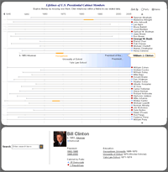
Table of Contents

1 Introduction 3
2 Project Description 3
2.1 Target Audience 3
2.2 Goals 4
2.3 Data Dimensions and Sources 4
3 Related Work 5
4 Design Process 6
4.1 First Iteration: Design Rationale 6
4.2 First Iteration: Known Issues 7
4.3 Second Iteration: Design Rationale 8
4.4 Second Iteration: Known Issues 10
5 Informal Evaluation 11
6 Future Work 12
6.1 Additional Data 13
6.2 Additional Functionality 13
7 Conclusion 14
Appendix A - Screenshots 15
Appendix B - Tools Used 19

1 Introduction
In a democratic society, information on the backgrounds and academic, social, and business connections of a nation’s leaders is an essential tool to support the democratic process. With Internet access at the public's fingertips, this type of information is theoretically easier to acquire than ever before. However, considering the volume, complexity, and disparate nature of this type of information, there is a tremendous need for it to be centrally compiled and presented in an accessible form. Surprisingly, we know of no publicly-available sources that attempt to do this in a comprehensive way.

In this final report on The Network, our Fall 2005 visualization project for IS247, we describe a design that could help researchers, journalists, and the general public visualize the myriad connections among U.S. officials via their affiliations with universities, companies and other institutions. We first survey examples of related work, then discuss our design process and rationale. Finally, we report on our informal usability evaluation results and share our plans for future work.

2 Project Description
This project endeavors to create a visualization of the network of presidential cabinet members and advisors for the Clinton and G. W. Bush administrations. The overall goal is to allow users to visualize connections between individuals, much like Friendster or Vizster, but to add more context to the relationships through multiple data dimensions.

The interface enables exploration of various data dimensions that individuals have in common: business and political connections, presidential administrations, university alumni membership, and birth state. The user should be able to see when these relationships started and the degree to which they interconnect over time.
2.1 Target Audience
The target audience for this visualization is threefold:

- Journalists – journalists often need to analyze data under tight time constraints and often do not have the leisure to dig into a data set in detail. This visualization offers a quick method for exploring cabinet relationships that might otherwise not be easily discerned.

- Researchers – this visualization provides researchers with a foundation for exploring relationships that can build the basis for future research.

- General Public – The Network makes it simple for members of the public to explore complex relationships that might otherwise require detailed research.

2.2 Goals
In addition to the specific goals outlined for each member of our target audience, we also aimed to accomplish the following with The Network:

- Simplify complex relationships – few visualizations exist in this area of research, most likely because the relationships between the various actors can become extremely complex. As discussed previously, there are flaws with the few existing visualizations in this space.
- Improve upon text-based compilations – Most compilations of this type of data are text-based (See Appendix A, Figure 1 and Figure 2), which make it difficult to see relationships between actors without combing through detailed data.
- Reveal non-obvious patterns – The advantage to using a visual tool for exploring these relationships is to discover patterns that would otherwise not be obvious to a researcher analyzing text-based data. In particular, visualizing this data will reveal if there are patterns between administrations and political parties that are not obvious by looking at the data in a non-visual format.
2.3 Data Dimensions and Sources
We set out to collect the following data on each cabinet and cabinet-rank member:
Name
Gender
Year of birth
State of birth
State of residence
Political party affiliation
Undergraduate institution and years
Graduate institution and years
Private sector connections and years
Appointed office held and years
Elected office held and years
Roles within administration and years
Military affiliation and years

We used several sources to gather this data, mostly from websites offering narrative overviews of cabinet members’ lives.
http://www.whitehouse.gov
http://www.americanprogress.org
http://www.sourcewatch.org
http://www.democracynow.org
http://www.infoplease.com
http://www.answers.com

We organized the data into a set of relational tables using MS Access: person, cabinet, company, role, and university. For simplicity, we listed universities that employed cabinet members (as opposed to educating them) in the university table instead of the company table. Time-frames turned out to be the toughest data to find, so we decided to leave this dimension out at least initially.

We imported this data into two visualization tools: Spotfire and Tableau. Each tool offered different features and visualizations that allowed us to explore the data and identify relationships between individuals. What proved particularly helpful was Spotfire’s profile chart (parallel coordinates) and Tableau’s bar charts. We were surprised by the small number of non-governmental professional connections—there are many one-off companies in our data set. Not surprisingly, a handful of Ivy-League universities dominated.

3 Related Work
Many articles have been written about the revolving door between public office and private business, particularly the G.W. Bush administration. There are very few, if any, visualizations that communicate the degree of relatedness between high-ranking officials in the presidential arena. We know of a single visualization, They Rule (see Appendix A, Figure 3), that attempts to convey the link between Clinton and Bush administrative officials to boards of directors of publicly-held corporations. Though it does not convey the variety and complexity of relationships we hope to include in The Network, They Rule provides a useful reference point, especially for interactive features.

They Rule uses a node-link network layout to show the interconnections of board directors of some of the most powerful U.S. companies (as of 2004). It is highly interactive, allowing users to browse or search individuals, companies, and institutions to add clusters of relations to the visualization. Users can also move, expand, contract and delete nodes to further customize the mapping. The interactivity encourages open-ended exploration, but They Rule does a poor job of distributing the nodes to prevent overlap and occlusion, making it difficult to read without constant readjustment of the layout.

The State Machine (see Appendix A, Figure 4) is a visualization of members of the U.S. Senate to different sources of campaign funding. The visualization uses forces of attraction techniques to show the degree of relationship between lobbyists and senators. The user has access to a control panel to display or suppress additional details and text labels on the visualization.

Vizster (see Appendix A, Figure 5) is an interactive visualization tool for online social networks. Vizster uses an undirected graph structure with friendships as edges and people as nodes. Selecting a node brings an individual into the center of the network and related nodes reorganize.
4 Design Process
4.1 First Iteration: Design Rationale
In our first attempts to visualize connections among cabinet members, we were heavily influenced by Vizster’s node-link network layout. We had difficulty imagining a better approach, so we focused on exploring this technique before considering other directions. We also drew upon two examples from VisualComplexity.org, 1) Critical Paths and Trajectories in Networks (Appendix A, Figure 6), a multi-domain visualization, and 2) Power Law Graphs (Appendix A, Figure 7), a graph/node example we used as inspiration as what not to do.

The major issues we grappled with initially were how to:
- encode the nature of the connections between people
- present the types of connections all at once, in isolation, and in different combinations without creating a dense, unreadable visualization
- allow user-manipulation of which types of connections are visible

In thinking through options for depicting connections in relation to people, we discussed the merits of making them edges vs. nodes. There was no doubt each person would be a node, but connections such as cabinet, employer, and university could go either way. If we made them edges, each type of connection could take on a different color, pattern, or grayscale density. Knowing that incorporating a variety of colors or patterns can get visually overwhelming and interfere with clarity, using grayscale seemed like a possibility. The more connections (each a different shade of grey), the thicker the overall line between two people would appear. Or, taking Gestalt properties into account, we could make the connecting line a lighter or darker gray to reflect fewer or more connections respectively.

Ultimately, including cabinets, employers, and universities as central nodes that satellite person nodes connect to won out. Clustering person nodes around connection type/institution nodes seemed like the clearest way to show the type and (approximate) quantity of connections. Using color to denote the party of cabinet members offered the added benefit of seeing the relative number of Republicans and Democrats associated with each institution.

Depicting connection types as nodes, however, posed our second primary challenge: how to present the connection types all at once, in isolation, and in different combinations. A view with all connection types visible would be too dense to read. Allowing users to turn connection types on and off would cause the visualization to re-render into an equally confusing mess of crisscrossing lines. We also considered a 3D view where each connection type could be on its own plane that would fade or become visible as a user “moved through” the visualization.

Anticipating that our target audience requires a simpler view, we decided to isolate connections types via separate views. A tab-based structure allows users to manipulate each view separately. Based on feedback from Marti, we incorporated the technique of small multiples; panes with tightly-coupled views of the geographic dimension (birth state, university or employer location) and a bar chart of aggregates in each party, cabinet, or university. These additional panes added potential for brushing and linking. Depending on the selected tab view (cabinet, employer, or university), we envisioned that clicking on a state would highlight a subset of related nodes. Users would also be able to select a single or group of nodes to highlight the related states. We chose the neon green highlight color to indicate selected data within the different panes and to ensure contrast with party and text label color.

We also added a pane with cabinet, gender, and text label filters to further enable data manipulation and information-hiding. These filters support common tasks of comparing cabinets and highlighting women vs. men. Selecting/deselecting cabinets would add/remove cabinet members from view, while selecting women or men (or both… not ‘none’ as our interface implies) fades the nodes/edges of the deselected gender. The use of the filters also affects the contents of the geography and aggregate panes. Clicking on a node brings up a details-on-demand window.

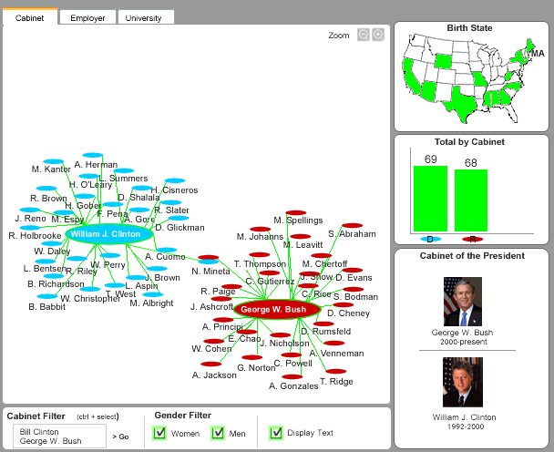
Figure 8. First design concept for The Network visualization.
4.2 First Iteration: Known Issues

Class and instructor feedback helped us recognize several weaknesses in our design choices. Since we chose the node disc shape somewhat randomly, a shape more semantically tied to or metaphorically representative of the data could convey connection information more effectively. Additionally, we agreed with comments that increasing node size to reflect a larger number of connections, a technique used in comparable visualizations such as They Rule, was unnecessary. In general, we needed to remind ourselves of the audience, tasks, and goals to get a fresh perspective on the design direction.

Reflecting on our original proposal, we realized that we sacrificed several important objectives with this design direction. It does not support the ability to see which cabinet members have the most overall connections or to see the specifics of each connection (e.g., university and company) at a glance, without having to switch views. We also dropped the time dimension—the years cabinet members attended a university or worked at a company—due to gaps in available data. We decided that subsequent design iterations should address these missing features and put the emphasis back on connections among people rather that among people and institutions.
4.3 Second Iteration: Design Rationale
In our second design, we focused on the time dimension as the main driver of the design. We also incorporated browsing and exploring timelines, searching, and using brushing and linking to show associations.
Based on feedback from our class presentation, we shifted direction away from a graph/node structure to an X:Y coordinate plane-based visualization in the hope that it would more clearly communicate the complex relationships between the actors in our data set.
Martin Wattenberg’s Idea Line
Idea Line provided us with the strongest inspiration as it manages to represent a complex data set simply and clearly. Additionally, it uses time as one of its primary dimensions, which was a critical feature we were looking to reincorporate into our work after having abandoned it in our first iteration.

According to Wattenberg, “The Idea Line displays a timeline of net artworks, arranged in a fan of luminous threads. Each thread corresponds to a particular kind of artwork or type of technology. The brightness of each thread varies with the number of artworks that it contains in each year, so you can watch the ebb and flow of different lines of thought over time.” Wattenberg is a master of working with complex data sets, and Idea Line both successfully shows relationships across data points and incorporates them into a clear timeline, both requirements for our data set.

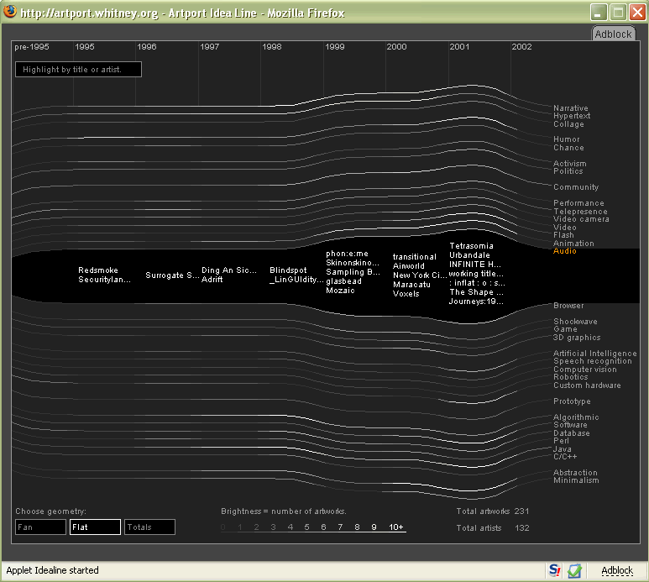
Figure 9 (Accessible at: http://artport.whitney.org/commissions/idealine.shtml)

Stephen Few
As we began to redesign The Network, we also drew upon the work of Stephen Few. We used his technique of bright and muted color to drive attention to the most important elements of the design – that is, the grid and lines, rendered in grey. This allows the interesting and interactive elements to become the focus of the visualization. When a milestone is selected from a lifeline, corresponding orange bars illuminate on related lifelines. The length of the bars in our visualization corresponds to length of time in a cabinet member’s life to date.
The Network employs several visualization techniques to communicate relationships:
Color
We use red and blue for the normative data elements of political party. These colors are already used for this distinction by the parties themselves and therefore are already meaningful. Our users easily made this identification.
Size
We used a larger font to draw attention to presidents. This allows for easy identification in an alphabetical list, and supports the assumption made by The Network that cabinets will typically be explored through presidential affiliation.
Details on Demand (DOD)
Our DOD module includes specific details about lifeline milestones, including exact dates not visible on the lifelines, as well as summary information such as the total number of Clinton and Bush cabinet members associated with a milestone. The module supports an alternate view of the data allowing users to make quick references, such as party affiliation. The DOD module also allows a consolidated list of related cabinet members instead of trying to detect them on the lifelines, forcing a heavy cognitive load (since users would need to traverse lifelines back to the list to decipher who is illuminated). Also, since not all lifelines are visible at once, this module provides a list view allowing for access to all related points even if they are not fully visible.
Search
The Network supports the ability to gather information when specific details about individuals are not known. For example, searching on “Texas” would quickly provide results instead of forcing the user to browse lifelines looking for users born in Texas if they did not know which individuals hailed from that state.
Interactivity
Finally, as conceptualized, The Network uses a high level of interactivity in its design. Like Idea Line, when users select a name the line expands, displaying the member’s biographical details and affiliations. When users hover over a data point, members with shared affiliations are displayed by highlighting the corresponding data points on their lifelines. Additionally, when a president or institution is selected, the Details on Demand module updates with specific data; users can also elect to click on links in the DOD window, which would spawn small menus or lists of matching cabinet members, each name linked to its respective lifeline. Finally, search results are also displayed in the DOD module, again with links to matching members or institutions.

An animated example of The Network is available in PowerPoint on our project website [http://www.sims.berkeley.edu/academics/courses/is247/f05/projects/thenetwork/The%20Network%20Demo.ppt].

4.4 Second Iteration: Known Issues
As we iterated through our redesign of The Network, we encountered the following issues:
Missing dates
Because this version uses time as a basis for its x-axis, all data included for each cabinet member must have dates associated with it. However, precise dates will not necessarily be available for every cabinet member’s role. Therefore, data without precise time intervals will either need to have estimates applied to it (if an accurate range is known) or left out entirely. This solution sacrifices quantity for accuracy, though for most of these public figures their public lives are well-documented enough that the amount of data missing time intervals is small.

Scalability
Due to time constraints and in recognition of this project as a prototype, we used a narrow data set (two presidential administrations) in order to test the validity of the idea. In order to be viable The Network would need to minimally include data from past (40-50 years) and future administrations to be truly useful. However, we are uncertain how well some of our design decisions will hold up under the burden of five or six times as many cabinet members in the data set and predict they will need to be revisited.

As we iterated through design revisions, we took note of some potential scalability issues. The space allotted in each lifeline, for example, is limited and adding additional biographical information for members with excessively long histories can make it difficult to fit data in the space and remain readable. Another issue is that as more members are added to the dataset, the vertical list of both names and lifelines will grow and require off-page scrolling. This means that not all lifelines will be visible at one time, obscuring some relationships. One solution we devised was to allow users to browse the full, unfiltered list of cabinet members using a fisheye view to allow a greater number of names to be displayed per page.

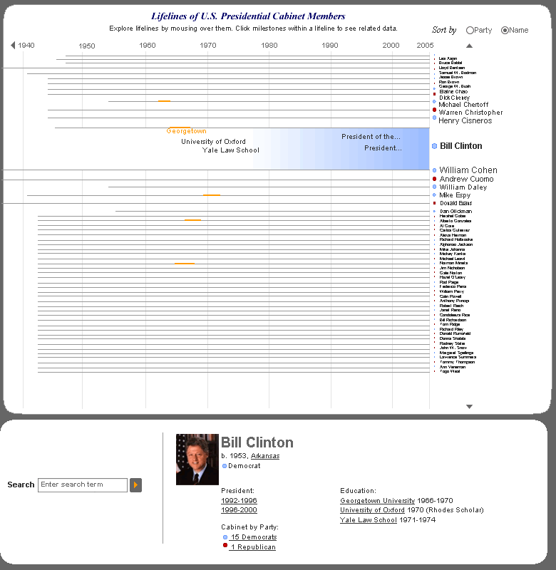
Figure 10. The fisheye menu is an alternative technique to address scalability of cabinet members.
5 Informal Evaluation
We conducted an informal evaluation of the second design iteration of The Network to identify potential design problems and to inform future work. We presented mockups to five participants and asked each of them to complete three tasks as well as to talk generally about the interface. Participants consisted of two male news reporters, one daughter of a California congresswoman, and two male SIMS students. All participants were in their late thirties and two have graduate-level degrees (two more almost have them).

Since the mockups were static, participants conveyed their expectations of the interface by asking questions and describing how they thought features would behave. From their questions and comments, we were able to garner a basic understanding of their mental model related to the data set. As they explained how they would complete the specified tasks, participants pointed out potentially confusing aspects of the design and described new features they would like to see added.

Even without a clear sense of the interactivity, participants were able to imagine how to complete each task, often by taking a similar course of action. Most relied on browsing the lifeline area to find specific companies and universities that cabinet members may have in common. One of the journalists said he thought many people using this interface for research would know a lot about certain individuals and would look for connections via their lifelines, at least at first. Others thought they would use search at least as frequently as browsing. Participants were split on whether they wanted more specific search features and filters, such as dropdowns with companies and universities in addition to keyword search, and one SIMS student (predictably) felt there should be support for faceted search (find all Stanford alums who also worked at the U.N.).

The most frequent questions were related to the interaction design, especially what mousing over items vs. clicking them trigger. All participants were unsure, but guessed that rolling over lifelines and milestones brought up or highlighted information temporarily while clicking made information “stick.” There was some confusion about whether search affected the arrangement of the lifelines and, if not, where search results would appear. Links in the details on demand window (e.g., the Georgetown link in Clinton’s details on demand) also raised the issue of whether Georgetown connections would be highlighted in the lifelines or whether only relevant lifelines would display.

Participants had a positive reaction to the visualization and expressed an eagerness to “play” with its functionality. The two journalists were especially interested in having more people and connections represented and being able to search on subgroups of data, such as industry sector. Several participants inquired if we intended to finish building the tool, as they thought it would be valuable and would fill a need that currently is not satisfied.

6 Future Work
There are a variety of directions The Network could take in the future, the least of which is to find interested developers (with better programming skills than ours) to assist us in building a functional prototype of the tool as currently specified. In particular, releasing a functional version of the tool to the public along with a method for contributing additional data to the database could expand the usefulness of The Network considerably.
As we worked on The Network, we also came up with ideas for new functionality and data that we thought would augment the tool but were unable to implement due to time constraints.
6.1 Additional Data
Expand Data Set
First would be considering expanding the scope of the database to include other members of an administration, such as deputy cabinet posts or other important posts that are not of cabinet-level status. Another expansion we considered could include the spouses or partners of each member in recognition of the influence immediate family relationships wield over social networks.
Add Data Points
Finally, additional data fields combined with new filtering capability would expand the types of relationships we could analyze. Some suggestions include fraternity/sorority membership, military affiliation, and religious affiliation.
6.2 Additional Functionality
Improve Visibility of Lifeline Details
Our user testing supported a feature that allows the user to see dates or details on mouseover of a highlighted portion of the lifeline. For example, selecting Georgetown University on Clinton highlights related lines. The user should be able to mouseover Madeleine Albright’s highlight to see details like “Professor of International Relations, 1987-1992.”
Filter Lifelines
As the data set grows, the visualization could support larger data sets by allowing lifeline filtering. The user would be able to specify specific cabinets, timeframe or other political roles such as senator. Only those lifelines would display instead of the complete set of data.
Scroll Lifeline Canvas
One possible feature for the future would be to allow the user to scroll backwards in time, browsing cabinet members from the first presidency through the present. Again, this type of feature accommodates more historical data beyond the Clinton and Bush administrations.
7 Conclusion
In its short life thus far, The Network has evolved considerably. Feedback from our in-class presentation helped us spot the flaws with our original design and find a design direction that better communicated our vision. Our usability testers validated our concept and provided us with valuable suggestions for functionality. While much work remains before The Network becomes a working reality, we were able to create a design concept that resonates with our target audience and proves to us the value of creating a visualization tool in this area.
Appendix A - Screenshots

Figure 1. Screenshot of CPTech.org’s Revolving Door Chart

Source: http://www.cptech.org/ip/health/politics/revolvingdoor.html

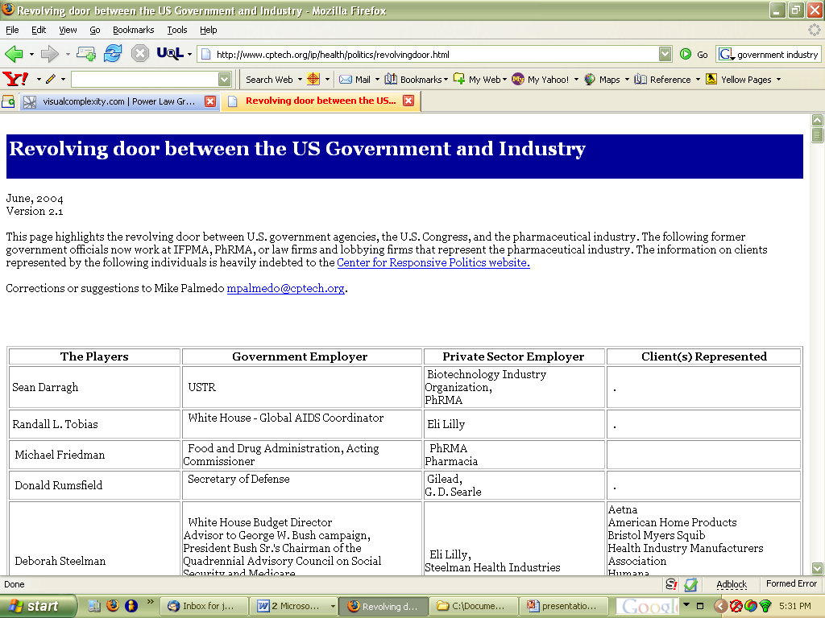

Figure 2. Screenshot of SourceWatch.org (text-based relationship mapping)

Source: http://www.sourcewatch.org/index.php?title=Government-industry_revolving_door

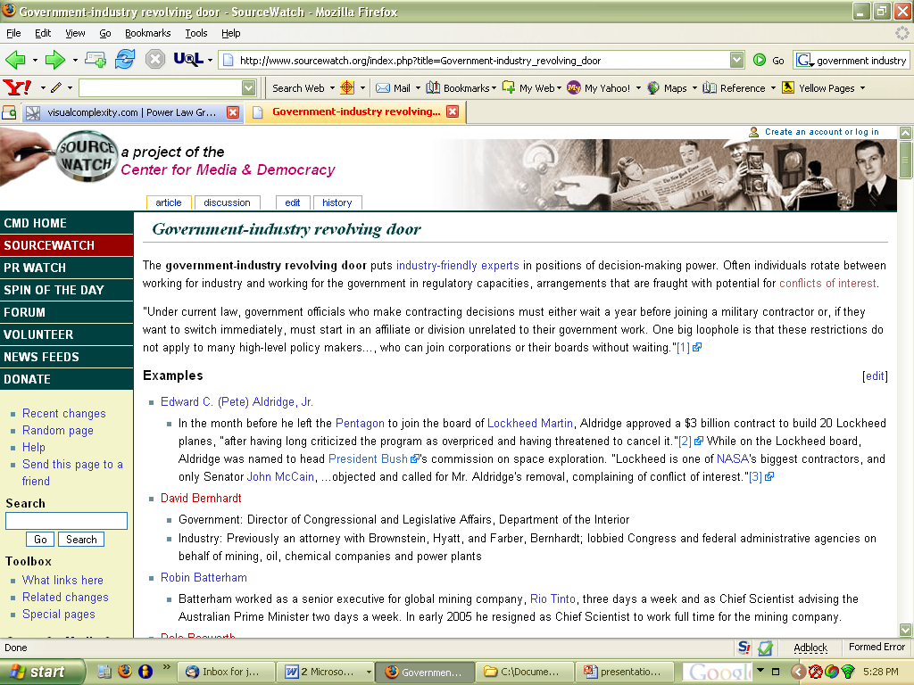
Figure 3. Screenshot of They Rule interactive visualization.

Source: http://www.theyrule.net/
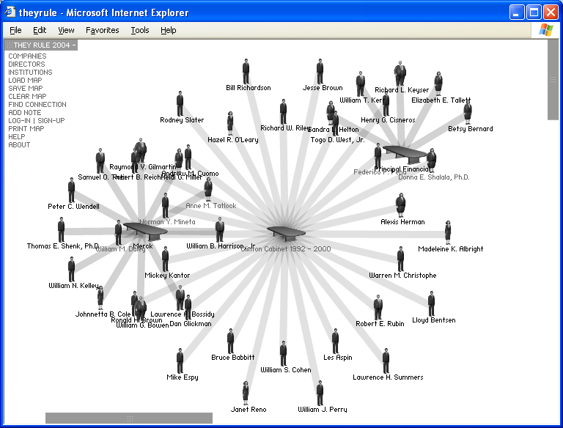
Figure 4. Screenshot of The State Machine interactive visualization.

Source: http://www.state-machine.org
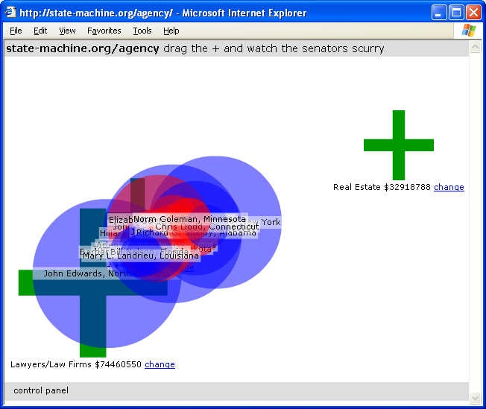
Figure 5. Screenshot of Vizster social network visualization.

Source: http://visualcomplexity.com

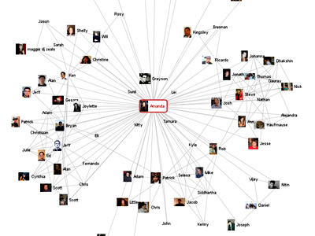

Figure 6. Critical Paths and Trajectories in Networks

Source: http://visualcomplexity.com
We drew upon this visualization for our first version as we thought it communicated complex relationships between multiple domains quite well. The graph represents “a time-sliced view of hypothetical network trajectories of individuals involved in the terrorist attack in Spain, March 2004.” Our notion of tabs in our first version corresponded to the three-dimensional layers in this image.

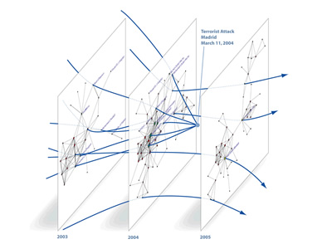
Figure 7. Power Law Graph

Source: http://visualcomplexity.com
This visualization, a “randomly generated power law graph of size 5000,” provided an example of what we didn’t want The Network to become – a tangle of relationships between actors so complex that the patterns are invisible and overpowered by the sheer amount of links between nodes. We thought The Network in its first iteration ran the risk of attempting to map too many relationships using the node/edge format.
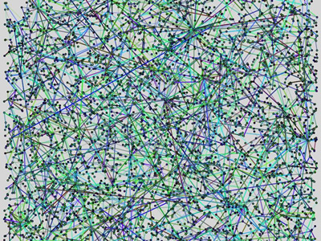
Appendix B - Tools Used
We used Macromedia Fireworks to design The Network. MS Powerpoint was used to animate features of The Network.

This concept is similar to the genealogy diagram presented by Mike Wooldridge and Jen King in class. See Appendix A for additional reference of design inspiration.

