Web Patterns Survey

Part I – Naming Page Elements
In this section, you are asked to review this web page, then name each section numbered and highlighted in red.

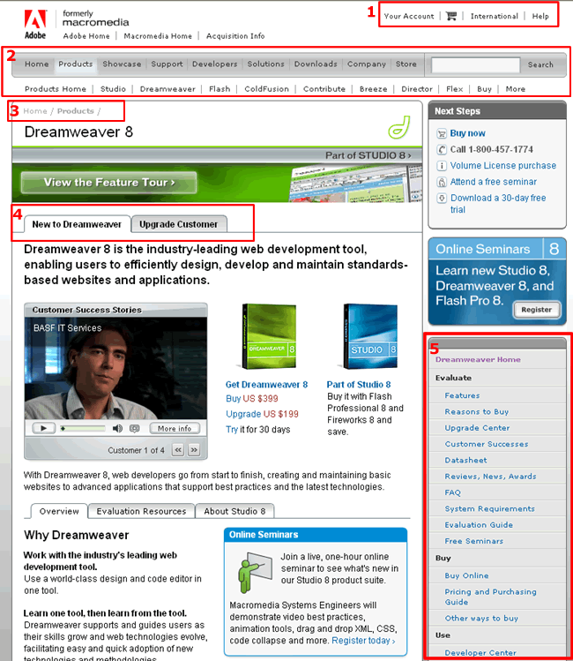

What is the best name for the design element highlighted on the Web Page?

1___________________

2___________________

3___________________

4___________________

5___________________

Part II – Revisiting Names
In this section, you are presented with the same elements you just saw. This time we have provided you with names, or you can use your own from the previous section. Place 1 next to the term that best describes the highlighted element, 2 next to the second-best term, and so on. You may enter your own terms if you wish - if you do, be sure to rank them, too.

1)
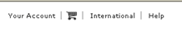

____ Global Navigation
____ Help Navigation
____ Navigation
____ Navigation Bar
____ Utility Bar
____ Utility Links
____ Other_________________
____ Other_________________

2)
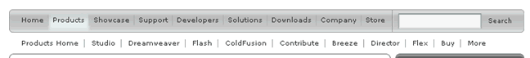

____ Double Navigation
____ Global Navigation
____ Horizontal Bar
____ Main Navigation
____ Navigation Bar
____ Stacked Navigation
____ Top Level Navigation
____ Other_________________
____ Other_________________

3)
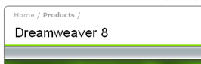

____ Breadcrumbs
____ Links
____ Location Breadcrumbs
____ Navigation
____ Navigation Links
____ Other_________________
____ Other_________________

4)
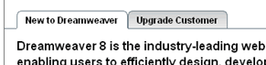

____ Navigation
____ Navigation Tabs
____ Tab Rows
____ Tabs
____ Other_________________
____ Other_________________

5)
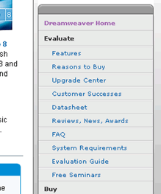

____ Contextual Navigation
____ Directory
____ Menu
____ Navigation Menu
____ Right Navigation
____ Vertical Navigation
____ Other_________________
____ Other_________________

Additional Elements
1)
____ Double Tab Menu
____ Navigation
____ Navigation Tabs
____ Tab Rows
____ Tabs
____ Other_________________
____ Other_________________

2)
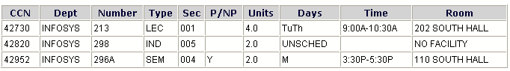
____ Course Calendar
____ Course Schedule
____ Course Planner
____ Course List
____ Other _________________
____ Other _________________

3)
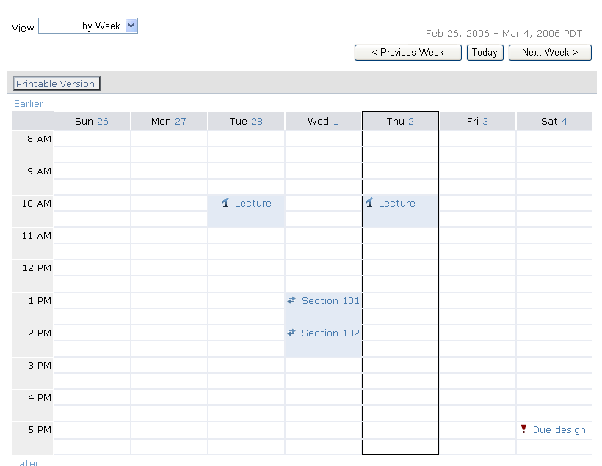

____ Course Calendar
____ Course Schedule
____ Course Planner
____ Course List
____ Other _________________
____ Other _________________

