PhotoCat Design Ideas
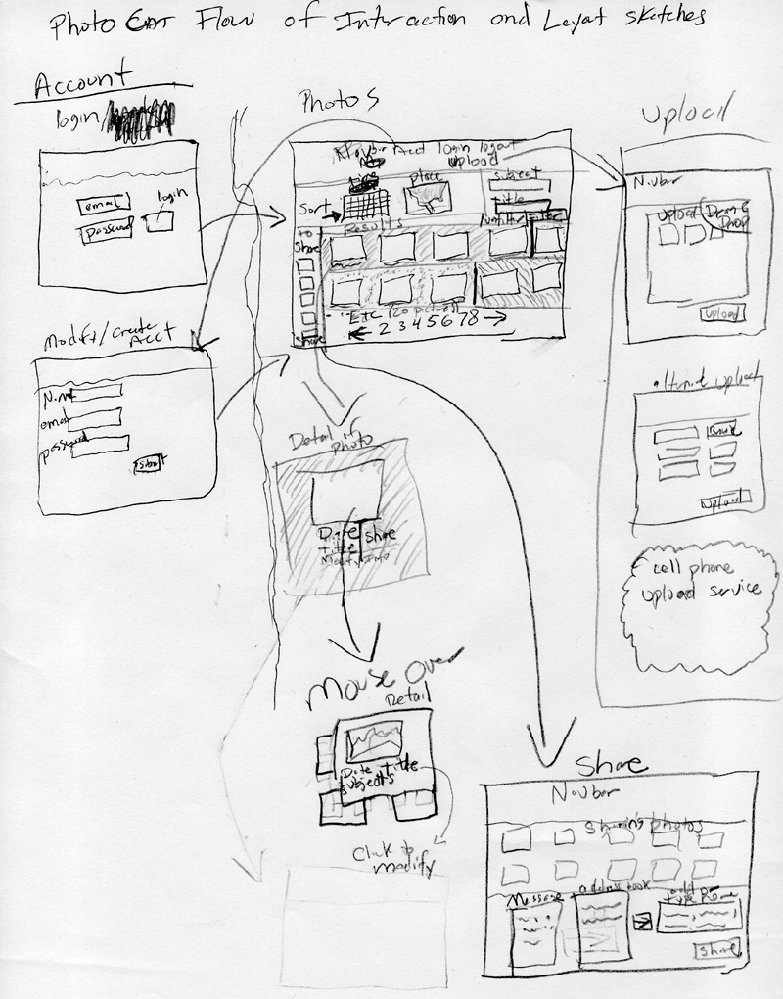

Explanation

Login/Account

The login and account creation is shown on the left. It uses email-address as the username to help simplify the process of for users and the program. By using the email address as the username, shares to other PhotoCat users can be easily found. An email address login may be useful to help users remember their login since they are not likely to forget their email address—though they may not remember which email address they used to obtain an account. This aspect isn’t so important, though.

Main Thumbnail Page

I designed the PhotoCat thumbnail page with the items most of our personas felt to be important. The ranking for both organizing and finding for important items was (in approximate order) thumbnails, date and time, subject(s) of photo, event, place and title. Subject was more difficult to organize by because it is would need to be user-entered data which may not be available for many photos, so it may not be useful to make it as necessary for organization.

Though maybe the design is too cluttered, it fits most of the relevant controls onto a page and doesn’t’ require clicking through multiple web pages and using the forward and back buttons as extensively.

Thumbnails are shown in the bottom part of the window with typical paging for moving forward and back through pages. Both pictures taken and shared from other people appear in chronological order here. The shared thumbnails could be differentiated in some way such as a colored border. The thumbnail area changes background color behind the thumbnails of different chunks in time. Possibly every time there is a time gap between photos of more than 6 or 8 hours the background can change color to indicate a new temporal grouping of photos. This could be an easy way to separate photos taken in a day (at least) and for some people would probably adequately separate events.

The navbar to different sections of the site is shown at the top of the page. It essentially directs people to logging in, logging out and uploading. The site doesn’t need many sections and extreme numbers of pages since I tried to leave most of the functionality easily accessible.

Jumping to a place in the photos can be accomplished with the item that looks like a calendar. It allows people to jump to a specific date (and page) in the thumbnails starting with that date. The place sort button is more problematic since I originally planned it to allow sorting by distance from a central location. This needs to be rethought, though. Place may need to be move elsewhere or removed since it is of lesser importance than many other items. Perhaps the place could be made a search or filter option.

The thumbnails show details of date and title. A share icon is near each photo and clicking it adds the thumbnail to the share list on the left side of the window. Clicking a thumbnail allows viewing the photo in full resolution.

When mousing over a thumbnail, a slightly large preview box is shown over it and some of the adjacent thumbnails (a mouse-over). It shows a larger preview (but not full size) of the photo along with more details about the date, title and subjects of the photo. Clicking the items in the mouse-over allow modification of date, title and subject information directly. Moving the mouse out of the mouseover box or thumbnails makes it disappear.

The share list on the left side of the window shows the pictures currently being set up for sharing. It has icons at the top or near each photo for doing things such as removing photos from the list, clearing the list or sharing the photos in the list. Clicking share from the share list brings up the share page which shows thumbnails of the photos being shared. It also has a place for a message, a place to type email addresses, and a place to add previously used email address to the To: area.

Another area near the top of the screen allows searching by subject key words or title key words. The search would show items by time, but limited to the subject. This functionality may be confusing and might need to be rethought since users may not know if they are in filtering or seeing the entire list.

Pictures may be uploaded by automatic upload from a cell phone, by drag-and-drop from the computer, or by a typical upload form if drag and drop cannot be used because of browser or security limitations.
Stacking groups of photos, another idea:

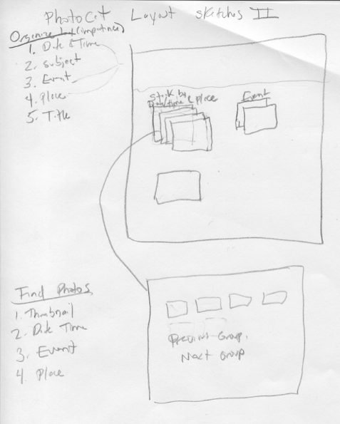

Another undeveloped idea I had was to group photos by stacks of photos which would allow seeing longer time spans on one screen. It would not allow visibility of all photos in a stack which could be a problem—though the stacking icon could indicate an approximate number of photos. A stack could be clicked to see the photos in the stack. I didn’t like this idea as well because it limited visibility to photos without going through a number of clicks. It also introduces difficulties of stack creation. An automated stack-creation is likely to make errors and annoy people since they don’t know which stack to look in. Forcing users to create stack couldn’t be relied upon, and forcing them to do so would be annoying to them.

