Judy Ma
SIMS 213
03/11/04

Individual Assignment

Question 1: Heuristic Evaluation

The intended functionality of the interface is to provide an overview of the guidebook, Rider Mel’s Mountain Bike Guide to Moab, and to allow the user to purchase the book through the website. To provide an overview of the book, the site has a short summary about the book’s features, movie clips and photos of Mel and his friends, a sample trail, and reviews of the book. If the user wants to order the guidebook online, he must go to the homepage and click on the ordering link there. Otherwise the user must print and fill out an order form and send it via postal mail.

Heuristic Violations

H4 Consistency
- Problem: A link in the left navigation and footer appears as “Photos & Videos” when you are on the homepage or on the Photos page. For all other pages on the site, the link same link appears as “Photos.”
  - Severity: 2
  - Fix: Change all occurrences of “Photos” into “Photos & Videos” in the left navigation and footer.
- Problem: The CCNow graphic for ordering the guidebook is not click-able whereas other graphics, namely on the Links page, are.
  - Severity: 3
  - Fix: Make the CCNow graphic linked to the ordering site and open the resulting page in a new window.

H1 Simple and Natural Dialog
- Problem: There is a variety of color for the links in the left navigation, the main content window, and the bottom frame.
  - Severity: 1
  - Fix: Choose one color for the links.
- Problem: The choice of colors for the interface is too bright and contrasting (red, yellow, and green).
  - Severity: 1
  - Fix: Limit the color-coding and choose more muted tones.
- Problem: The grouping of the links in the left navigation is random.
  - Severity: 2
  - Fix: Group by guidebook overview and ordering information.
- Problem: The Ordering page is confusing. The CCNow graphic is not click-able but the wording on the page makes it seem like the user can click it and order the book. Also, there are too many “OR’s” on the page, making the ordering instructions difficult to understand. (see screen shot below)
  - Severity: 4
  - Fix: Make the CCNow graphic linked to the ordering site and open the resulting page in a new window. Fix the wording so that it is clear the user has only two choices: He can click on the CCNow graphic to order online, or fill out the order form and mail it in.

H2 Speak the user’s language
- Problem: The “About Rider Mel” misleads the user to think that the page is about the person Rider Mel. Instead, it is about the book and not the person who wrote it.
  - Severity: 3
  - Fix: Either change the link’s wording to say “About the Book” or change the content of the page to be about the person Rider Mel.

H6 Clearly marked exits
- Problem: After clicking on the order link, the user is unable to return to Mel’s site. The Back button just keeps refreshing the CCNow page. If the user wants to return to Mel’s site, he must click on the link at the CCNow ordering page, which then displays Mel’s site in a frame. Thus, the user is trapped within the ordering frame without any way to get rid of it. (see screen shot below)
  - Severity: 4
  - Fix: Have the CCNow ordering page open in a separate window.
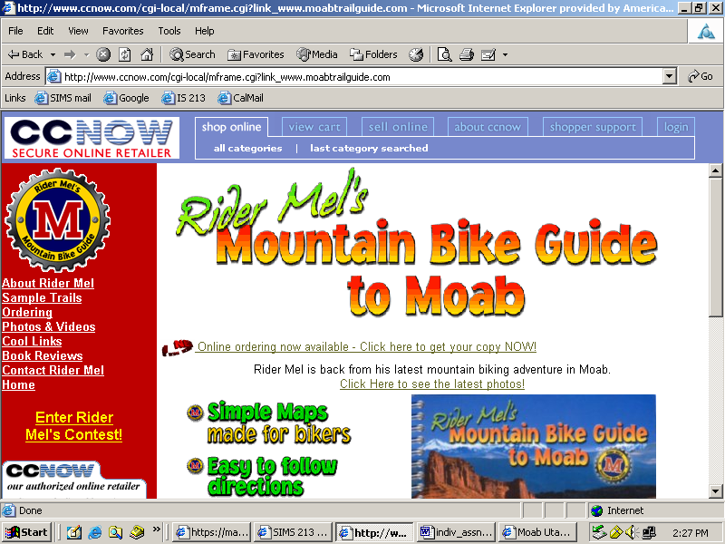

Question 2: Bicycle Gearshift Redesign
In order to redesign the gearshift as successfully as possible, I would first do a needs-assessment to determine the level of bike-riding experience of the typical user. There are many different types of bike riders – professionals who compete in races, people who ride for exercise, those who ride occasionally for fun, etc. Assuming that the user is not a professional, and only rides for exercise or for recreational purposes, I would redesign the gearshift so that the he would only need to think about pedaling harder or easier. The bike would still keep the two levers on each handlebar. The gearshifts on the left side of the handlebars still control the front gear and the gearshifts on the right side still control the back gear. Pressing the larger silver lever inward would make pedaling harder, while pressing the smaller black lever inward makes pedaling easier. For example, if the user wanted to make pedaling harder in general, he would press the larger levers on both sides. If he wanted to make pedaling harder in the front only, he would press the larger lever on the left. If he wanted to make pedaling harder in the back only, he would press the larger lever on the right. With this design, the user does not have to think about how shifting to a larger or smaller gear would affect the ease of pedaling. All there is to remember is that the larger levers makes pedaling harder and the smaller levers, easier.

To make operating the gearshifts easier and more intuitive for the user, I would put more distance between the silver and black levers, so the user can quickly shift gears without pressing the wrong lever. I would also give the silver lever more resistance, since it represents pedaling harder, while the black lever would be easier to push because it represents pedaling easier. For those users who do not have large hands or a strong grip, I would lower the gearshift mechanism facilitate shifting gears and also to brake.

The user has the option of thinking in terms of gears by looking at the gear speed indicator. But if it is too confusing for the user, it can also be ignored since it is not crucial for the user to understand it in order to shift gears successfully. This indicator sits in the middle of the handlebars, like a speedometer. Whenever the user shifts up or down, the numbers change to reflect the gear speed. The top number corresponds to the front gear, while the bottom number is the back gear. This interface is a full mapping of the indicator onto the gears. The indicator also provides feedback to the user, letting him know that the gearshift mechanism is operating correctly and that his actions are having an effect on the bike.

 | Left-side | Right-side
 | Front Gear | Back Gear
Pedaling harder (silver lever) | Shifts to larger gear | Shifts to smaller gear
Pedaling easier (black lever) | Shifts to smaller gear | Shifts to larger gear

This part of riding the bike is abstracted away so that the user does not have to think about whether he should shift to a larger or smaller gear in order to pedal harder or easier.

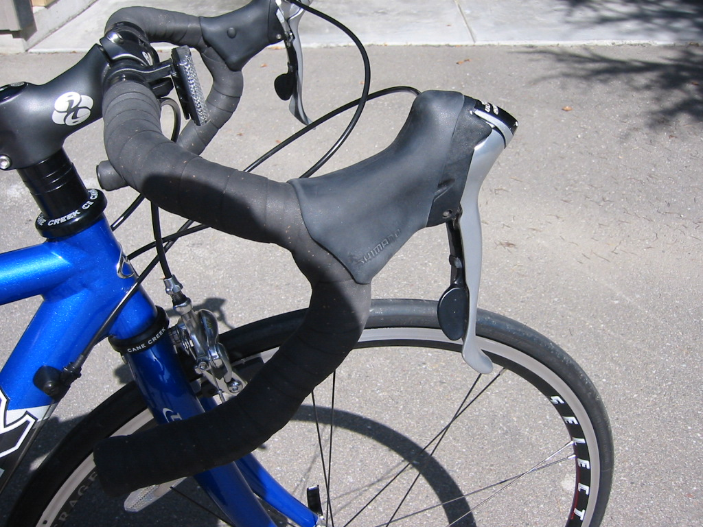
3
5
Gear speed indicator
Move the gearshifts lower, towards the midpoint of the handlebars, to facilitate changing gears and braking.
Separate out the two levers to make it easier to shift quickly.

