DENIM 1.0 User’s Guide

By James Lin, Group for User Interface Research, UC Berkeley
This user’s guide leads you through the basics of creating, editing, and running a web site design in DENIM. There are also exercises to guide you through the creation of a “news” site.

Terminology
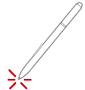
DENIM was designed with a pen interface in mind. Therefore, we will use pen-based terms for describing the interaction between the designer and DENIM.
Tapping means to tap the point of the pen on to the screen or digitizing tablet. Tapping corresponds to clicking the primary button on a mouse.
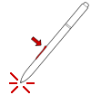
Tapping and holding means to press the point of the pen on to the tablet, and then holding the pen down. In DENIM, tapping and holding is used to select an object. You can let go of the pen once selection handles appear around the object you are selecting. Tapping and holding corresponds to keeping the left mouse button down and keeping the mouse stationary.
Barrel-tapping means tapping the pen while holding the button on the barrel of the pen. This corresponds clicking with the right mouse button. In DENIM, barrel-tapping is used to bring up a pie menu, which is described in more detail in section 2.

Elements of the DENIM Environment
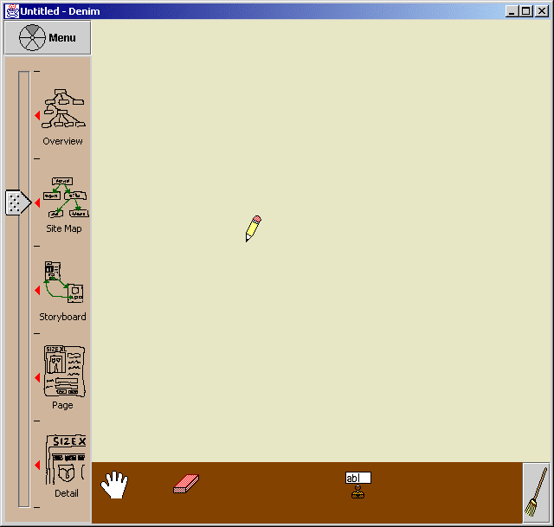
The DENIM window has three main parts.
Toolbox
Zoom slider
Canvas
- The zoom slider controls the zoom level at which you view your web site design.
- The toolbox contains various tools that you can use while designing.
- The canvas is the area where you sketch your web site design.
You will see how to use each of these elements in the tutorial below, when we go through setting up an example web site.

Basic Interaction
There are two basic ways to issue commands to DENIM. One is to access a command through pie menus. To open a pie menu:
- Barrel-tap on the canvas, or
- Press the menu button in the upper left-hand corner of the DENIM window
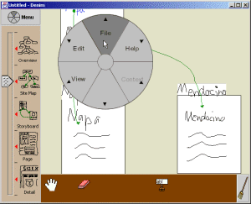
The other way is through gesturing. In DENIM, gesturing means pressing the button on the pen barrel while drawing the gesture. Some of the most commonly used commands have gestures as shortcuts.
The following images show the effect of a pan gesture.
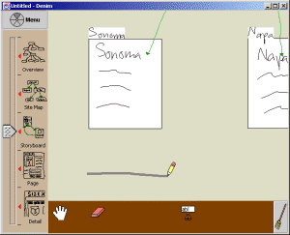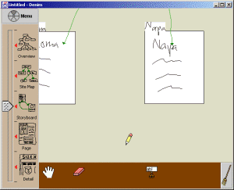

Creating a Web Page
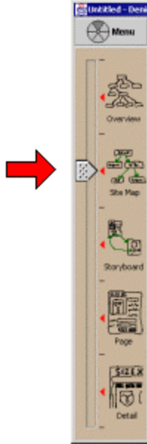
We will now illustrate how to design a web site with a specific example. Suppose you have been asked to design a news web site. The site will have a home page, and seven main sections: Front Page, World, Local, Business, Sports, Living, Weather.
When you first start DENIM, the cursor is a pencil and the zoom bar looks like the picture on the left. This means you are in Site Map view.

At this level, you create a web page simply by writing a short word or two describing what the page will contain, such as the page’s title.
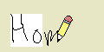

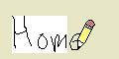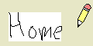
DENIM creates a blank web page with the words as the page’s label. At this level, you can only see the label of a blank web page.
Another way to create a blank web page is to gesture a caret on the canvas. Then, type in the label of the page in the dialog box that appears. When you press OK, a label with the words you typed in appear on the canvas where you gestured the caret.
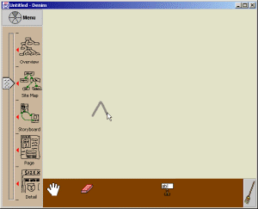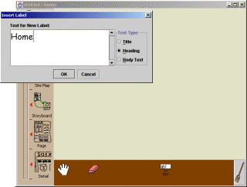
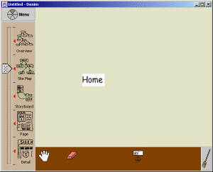

Editing the Site Map
After creating several web pages, you may want to move the pages around or erase pages.

Moving Pages
To move a page, barrel-tap on the page to select it. Selection handles will appear around the page. Then, drag the page to move it.

Erasing Pages
There are several ways to erase a page.
- Gesture a  over the page, like this:
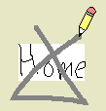
(Actually, this cuts the page into the Clipboard.)
- Tap on the Eraser at the bottom of the toolbox. The Pencil is swapped with the Eraser. Then tap on the page you want to erase.
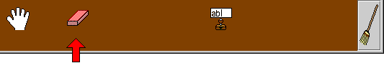
- Tap and hold on the page to select it. Then press Backspace or Delete on the keyboard.
- Bring up a pie menu over the page and select Edit, then Delete.

Showing Relationships Between Pages
Now you want to show that two pages are related, for example, that visitors to the news site will likely start at the Home page, and then go to the Local page.
To show this, draw a line between the Home and Local pages. DENIM turns the line into a gray organizational arrow. Organizational arrows have no semantic meaning to DENIM, so you can use them to denote any type of relationship you want.
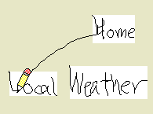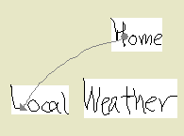

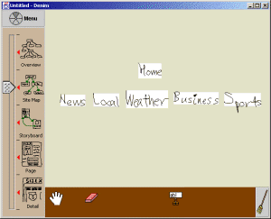
Exercise:
Draw organizational arrows between pages so that your design looks like this:

Now would be a good time to save your work.

Editing the Contents of a Page
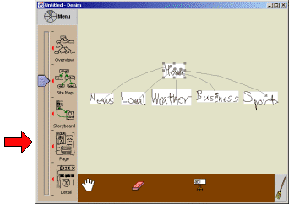 | Let’s edit the contents of the Home page. To zoom in on the Home page, tap and hold the page’s label to select it. Then tap on the second icon from the bottom in the zoom slider area:
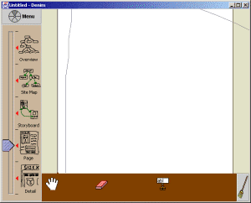 | This zooms the canvas to Page View. The Home page becomes visible and takes up most of the canvas.
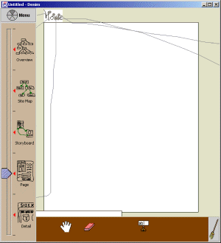 | You may have to resize the window to see the whole page.
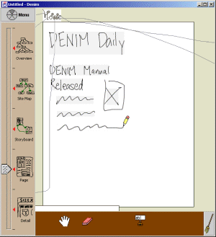 | At this point, you can sketch whatever you like. The gray boxes surrounding some of the ink indicates that DENIM has grouped the ink into a phrase. Later, when you create a link by drawing an arrow from a phrase, the whole phrase becomes a link.

You can erase your sketches just like whole web pages, through the pie menu, gesture, or Eraser tool as described in section 4. You can also undo, redo, cut, copy, and paste:
Command | Pie Menu | Gesture | Keyboard (Windows or Unix) | Keyboard (Mac OS X)
Undo | Edit→Undo |  | Ctrl+Z | +Z
Redo | Edit→Redo |  | Ctrl+Y | +Y
Cut | Edit→Cut |  | Ctrl+X | +X
Copy | Edit→Copy |  | Ctrl+C | +C
Paste | Edit→Paste |  | Ctrl+V | +V

Exercise:
Fill in each of the pages in your web site. Here is a sample design:
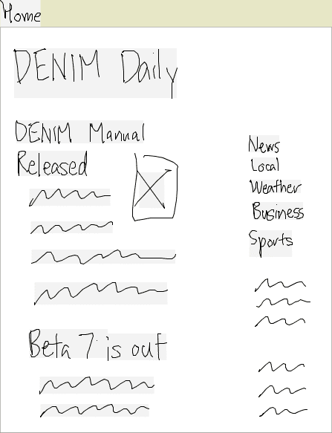Home | 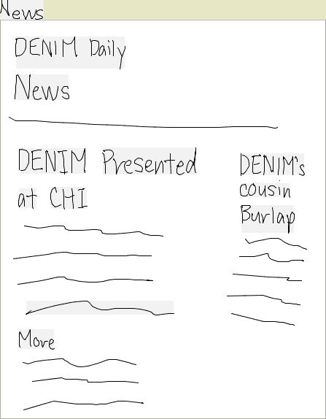News | 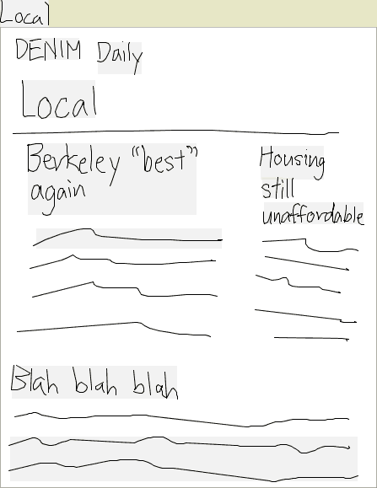Local
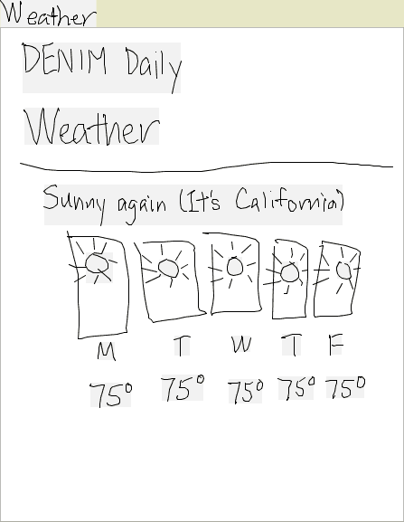Weather | 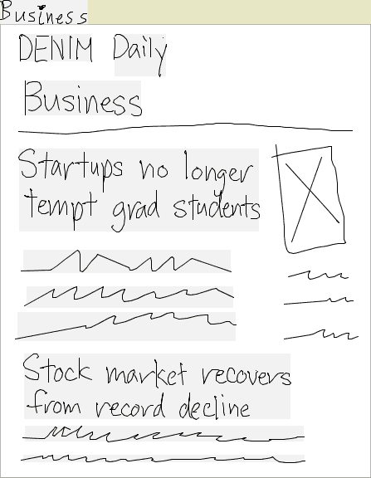Business | 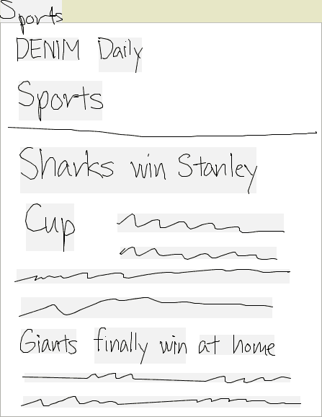Sports

Now would be a good time to save your work.

Adding Text to a Page
Writing lots of text by hand can be slow and messy, especially if you are using a mouse. DENIM also supports entering text with the keyboard. In section 3, we describe creating a web page by typing in a new label. There are two other ways to create and interact with text in DENIM:
- Creating and editing text within a page
- Replacing ink scribbles with text

Creating and editing text within a page
To add text to a page, simply gesture a caret in the page and type the desired text in the dialog box. The first letter of the text will appear where you gestured the tip of the caret.
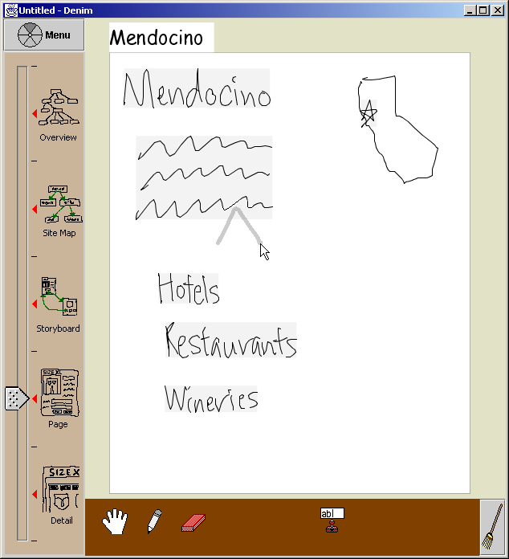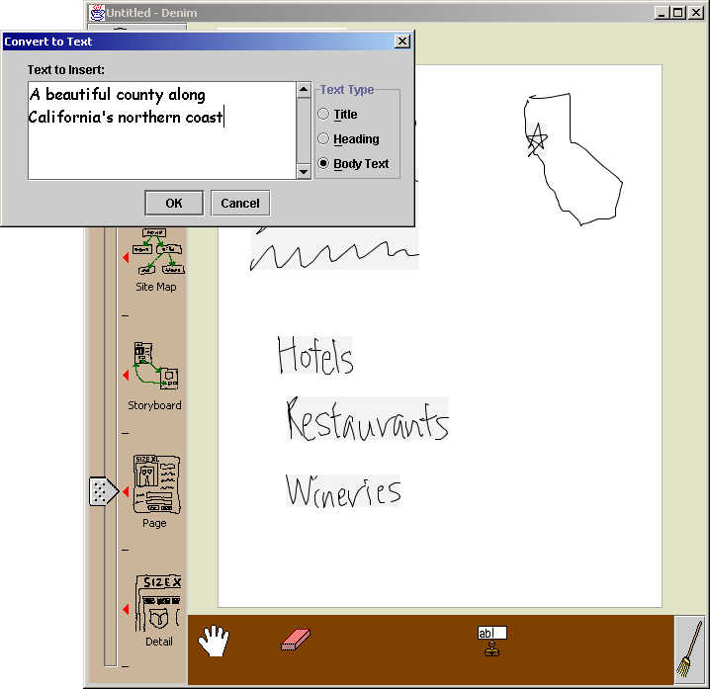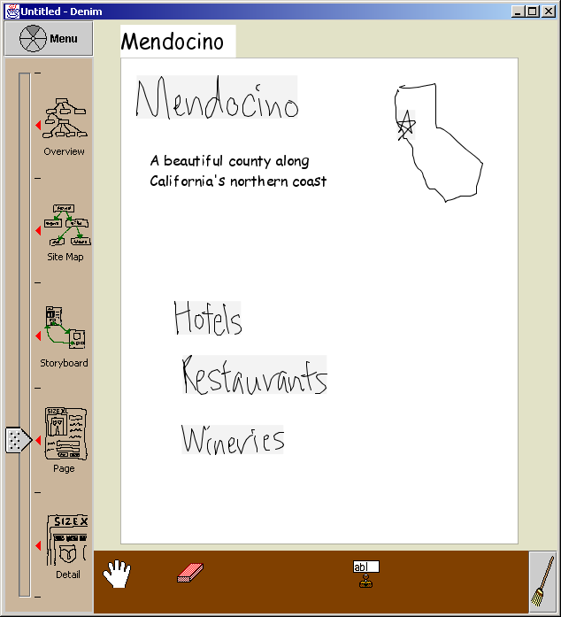
To edit the text, gesture a caret over the text. A dialog box will pop up with the text inside.

Replacing ink scribbles with text
To edit the text, gesture a caret over the ink and type the desired text in the dialog box. The first letter of the text will appear at the upper left-hand corner of the replaced ink.

Adding Text Fields to a Page
DENIM allows you to add text fields to your web site design. This is useful for prototyping web forms that are often used in e-commerce web sites and registration pages.
To add a text field to a web page, first tap on the Text Field stamp in the toolbox.
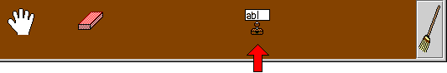
Then, tap inside the page.
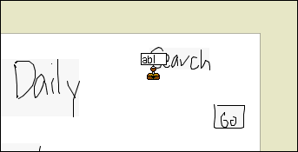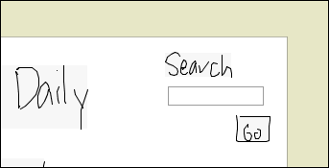
Any text you type in the text field will show up by default in Run mode (discussed in section 11).

Navigating Around the Canvas
DENIM provides several methods for moving around the canvas: panning and zooming.

Panning
To pan the canvas, there are three methods:
- Gesture in the direction of the object you want to see. For example, if you want to see a web page that is off the right edge of the window, then gesture to the right.
- Use the cursor keys. Pressing the right arrow key is the same as gesturing to the right.
- Pick up the hand tool from the toolbox, and click and drag it around the canvas to move it.
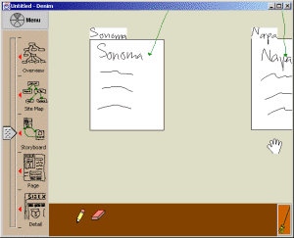 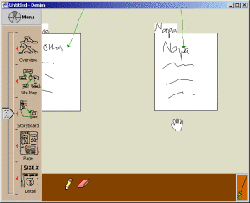
drag

Zooming
DENIM has five main zoom levels:
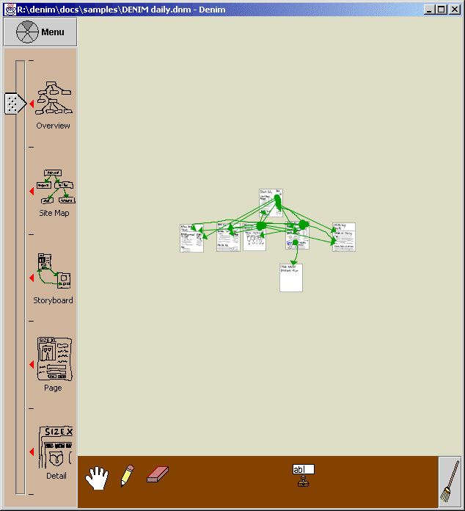  Overview | 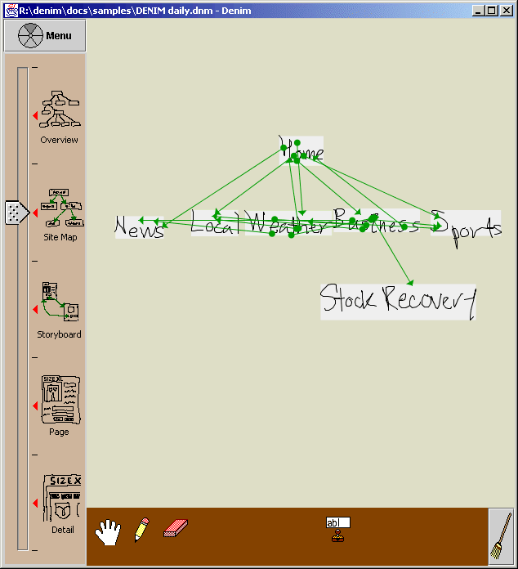  Site Map | 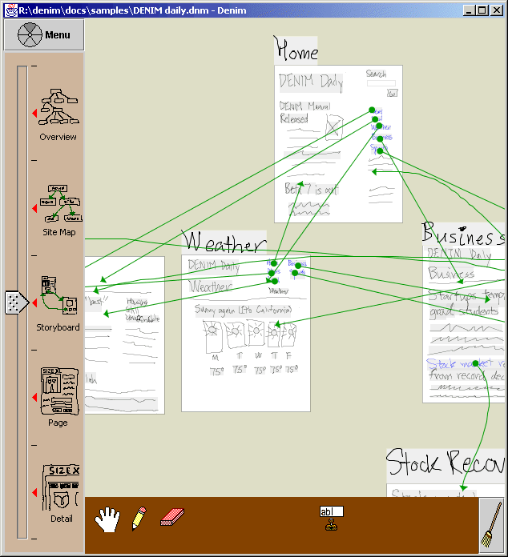  Storyboard
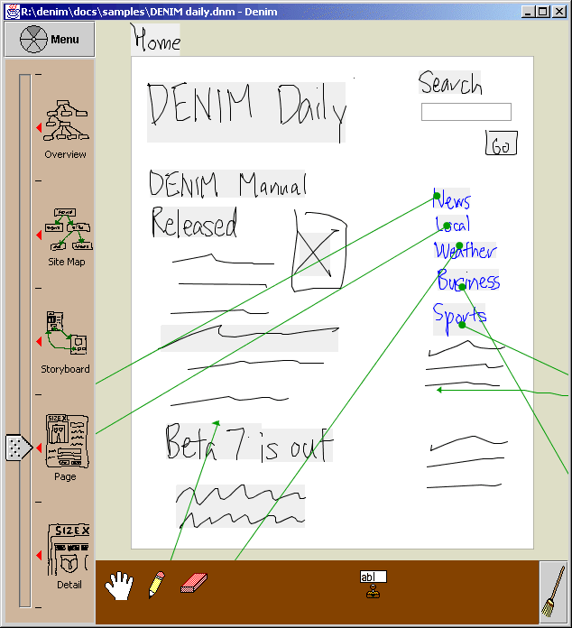  Page | 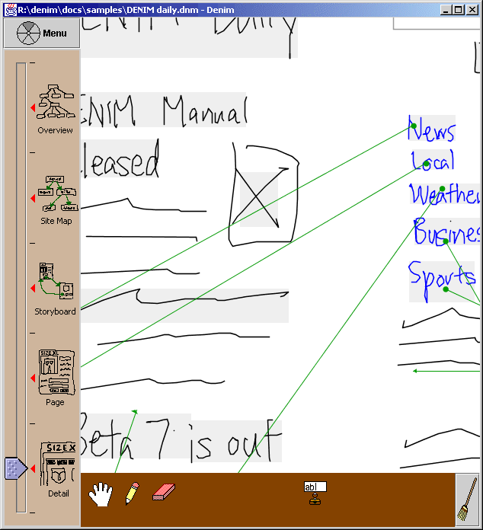  Detail
There is also one zoom level between each main zoom level, one above Overview, and one below Detail View.
To switch between zoom levels, there are two methods:
- Tap on the zoom level you want in the zoom slider.
- Press Page Up or Page Down on your keyboard to zoom out or in.

Linking Pages Together
Now you want to create a hyperlink between two pages. For example, you would like to link Local in the Home page to the Business page.
To show this, draw a line from Business in the Home page to the Business page. DENIM turns the line into a green navigational arrow, and Business becomes blue. Also, the organizational arrow between the Home page and the Business page disappears.
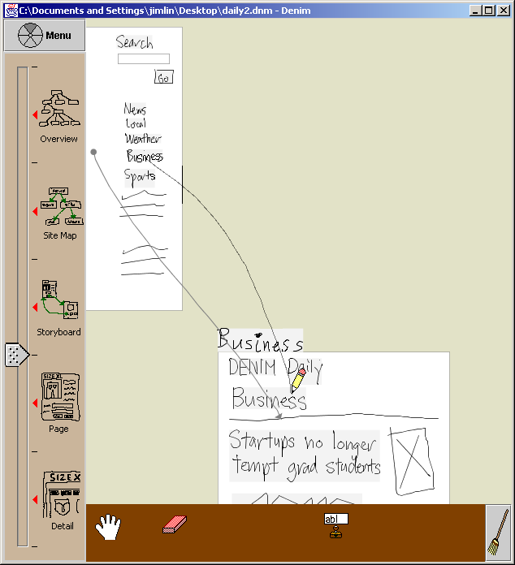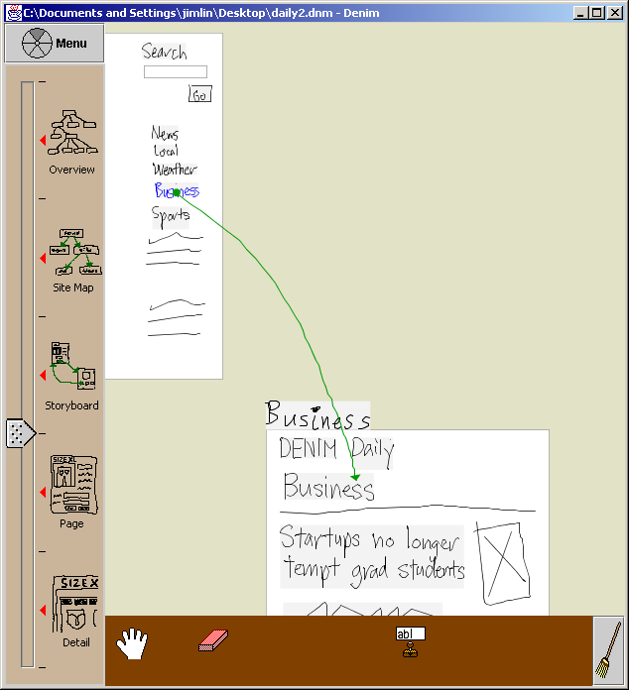
When is an organizational arrow created vs. a navigation arrow?
- An organizational arrow is created when you draw from the label of a page or a blank part of a page to another page.
- A navigational arrow is created when you draw from a phrase or other ink on a page to another page.

Exercise:
Draw navigational arrows between pages. Here is an example:
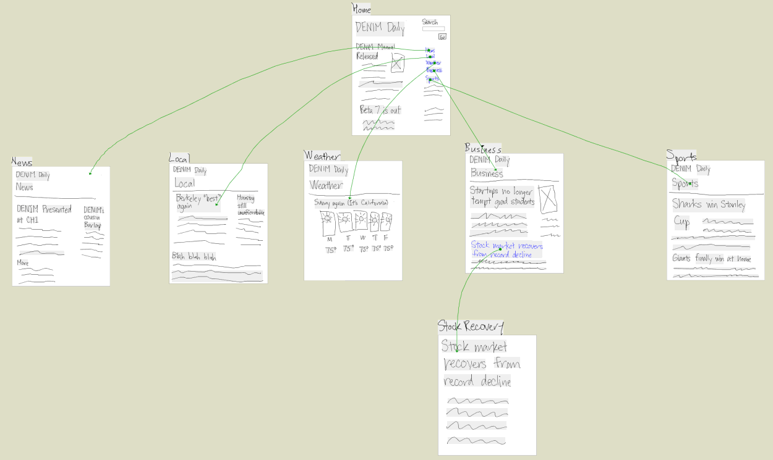
Now would be a good time to save your work.

Interacting with the Web Site
Now that you have created an initial design of the web site, you can test out the interaction of the web site by going into DENIM’s Run mode. To go into Run mode, barrel-tap on the Home page of your web site to bring up the pie menu. Then choose Project->Run.
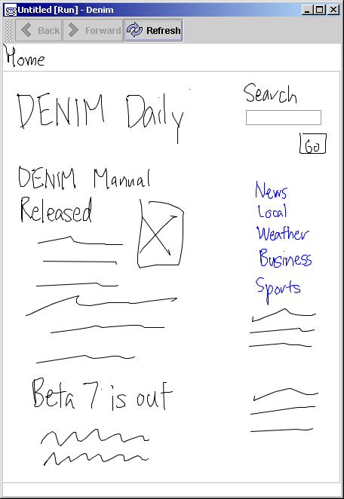 | A separate DENIM browser window pops up with the contents of the home page. The Back and Forward buttons behave as you expect. You can even switch to the main DENIM window, modify a page, and then go back to the browser to see your changes. If you modify the page that the browser is currently displaying, you have to press the Refresh button to see the changes.

Exercise:
- Go into Run mode and interact with your site design.
- Add today’s date to the home page. Then go back to the browser to view the changes.
Now would be a good time to save your work.

That’s It!
Thanks for using DENIM! If you have any questions about DENIM, please e-mail
denim-dev@guir.berkeley.edu.

