Saifon Obromsook
INFOSYS 213

Project Heuristic Evaluation Assignment

Project Evaluated: SIMians Course Comment Forum

- [H3 User control and freedom] (Severity 2)
The screen that displays each course has ‘view system rating’ link.

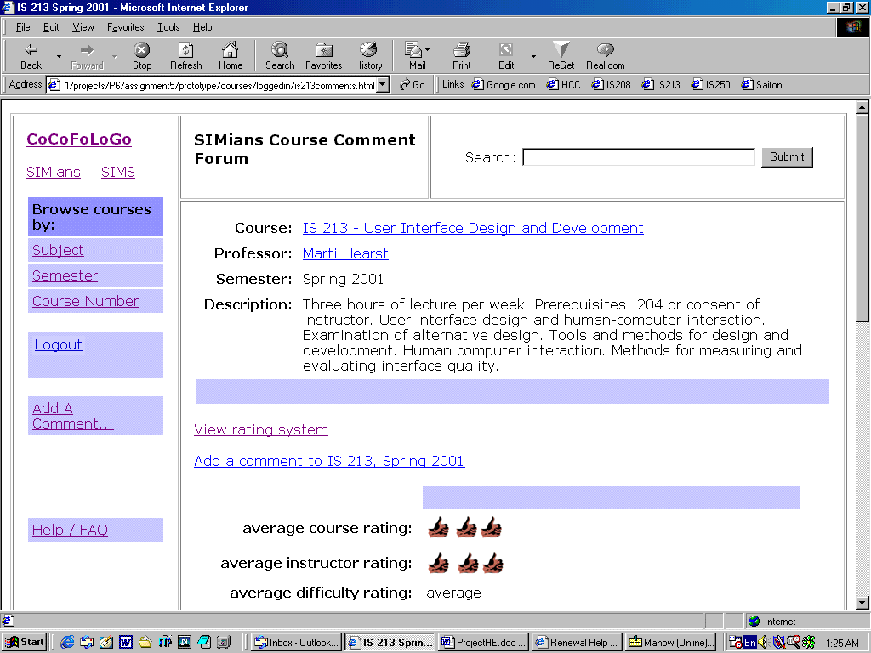

Once users click on this link, they cannot go back to the course description page (which is the next step they are mostly to perform) without clicking the ‘back’ button. It only provides links to the course listing screens.
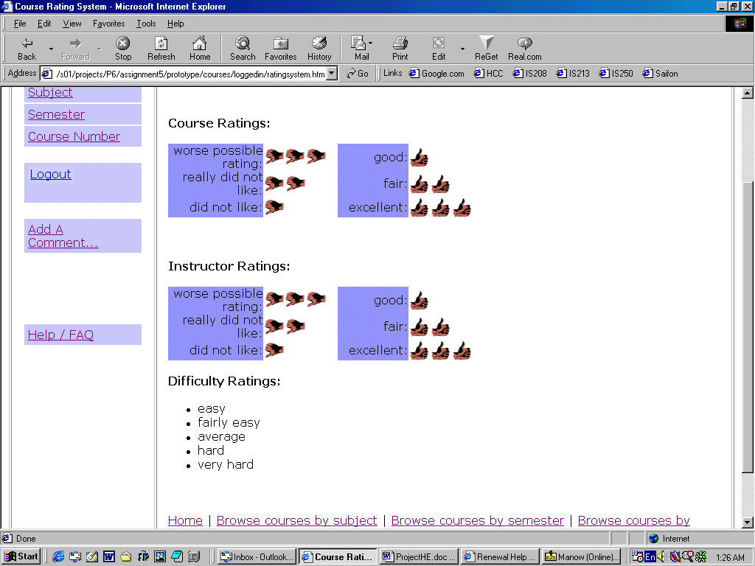

Suggested Solution: Add a link to the course description page on the ‘system rating’ screen.

- [H2 Match between system and the real world] (Severity 1)
The interface uses the word ‘average’ for average rating. This might be a little confusing for difficulty rating since ‘average’ can also refer to a level of difficulty. The conventional word used is ‘overall.’
Suggested Solution: Change ‘average’ to ‘overall.’

- [H2 Match between system and the real world] (Severity 2)
In the add comment screen, it is not clear what ‘continue’ button does. Users might wonder whether it will submit the rating/comment or gives a preview.

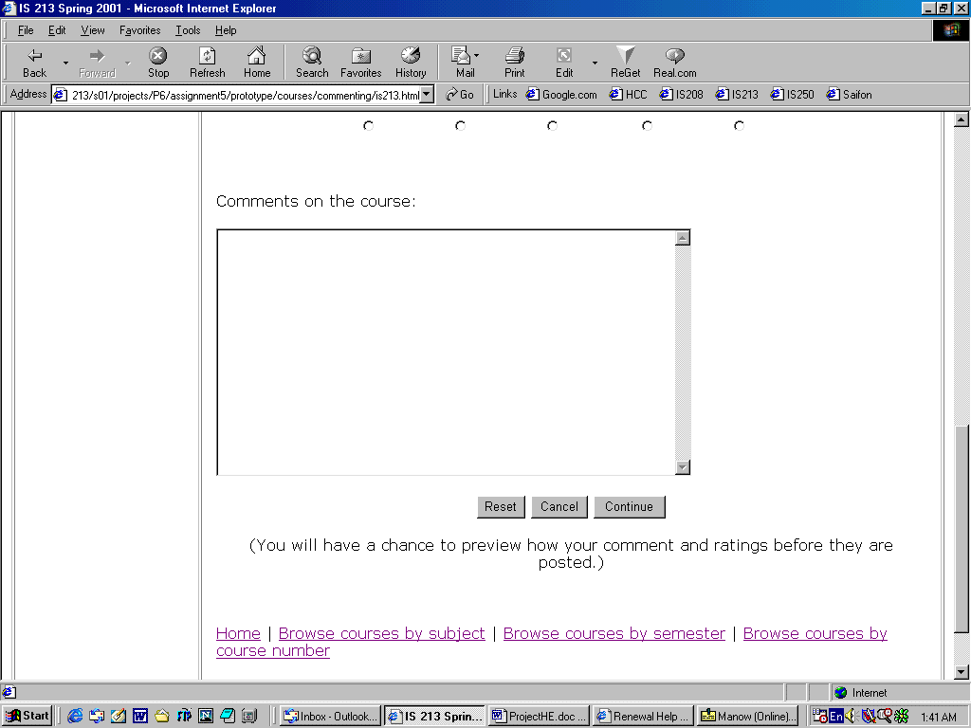

Suggested Solution: Replace ‘continue’ button with ‘preview’ button and ‘submit’ button.

- [H7 Flexibility and efficiency of use] (Severity 2)
For this interface, this ‘continue’ button seems to refer to previewing the input. Having only this button is not sufficient because users might want to take a shortcut by submitting the input directly without previewing it.
Suggested Solution: Same as #2.

- [H2 Match between system and the real world] (Severity 2)
After clicking ‘continue’ button, the following screen appears. It is not clear, however, whether ‘Edit comment’ button only refers to the comment part or both the rating and the comment. It is not clear either whether ‘Add comment’ button means submitting this comment or adding another comment (like what ‘Add a comment’ link does). The first time I used the interface, I thought the button refers to adding another comment.

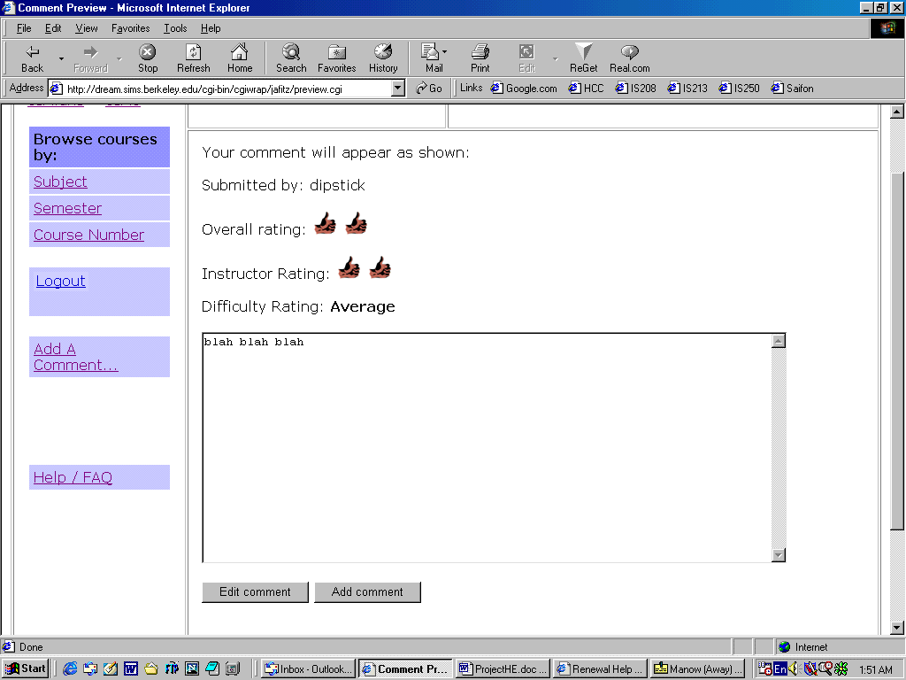

Suggested Solution: Replace ‘Edit comment’ with ‘Edit’ and replace ‘Add comment’ with ‘Submit.’

- [H1 Visibility of system status] (Severity 1)
On the following screen, choosing an item in the drop-down list will automatically direct users to the corresponding course description page. Although this might serves as a shortcut, it gives poor feedback to users’ input. It might be better to wait for users to click ‘go’ button before proceeding to the next screen so they can be sure of the choice selected, and not be brought to a wrong page if they accidentally choose a wrong course from the list.
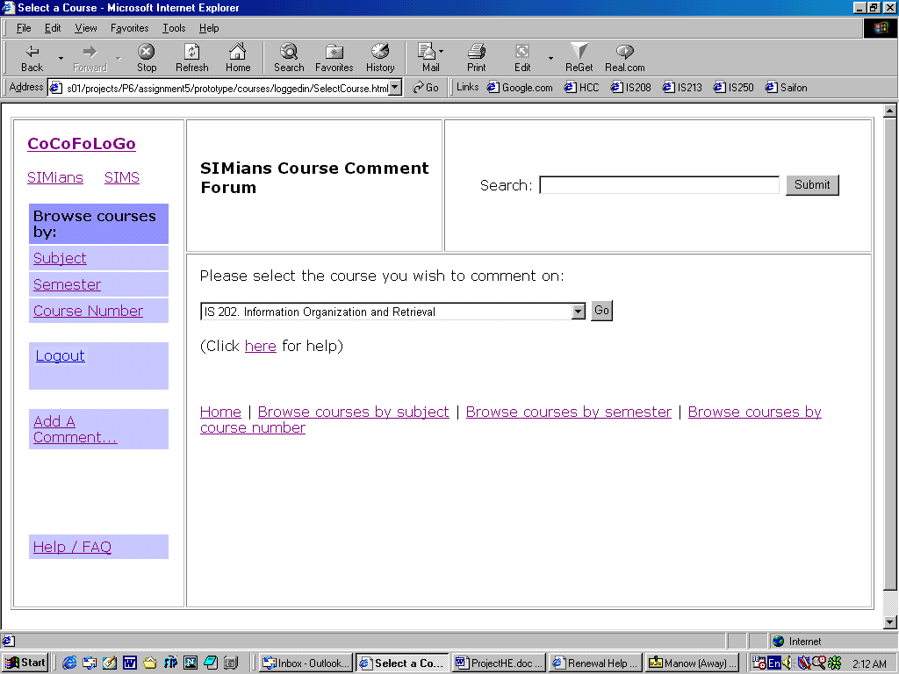

Suggested Solution: Modify the system so that it waits for users to click ‘go’ button before proceeding to the next screen.

- [H10 Help and documentation] (Severity 1)
In the Help / FAQ section, there are separate links tailoring different users’ tasks. Each link corresponds to an individual page for each help section. However, users might want to read more than one sections at a time, which can be accomplished only by clicking back and forth between ‘Help / FAQ’ link and each topic’s link.
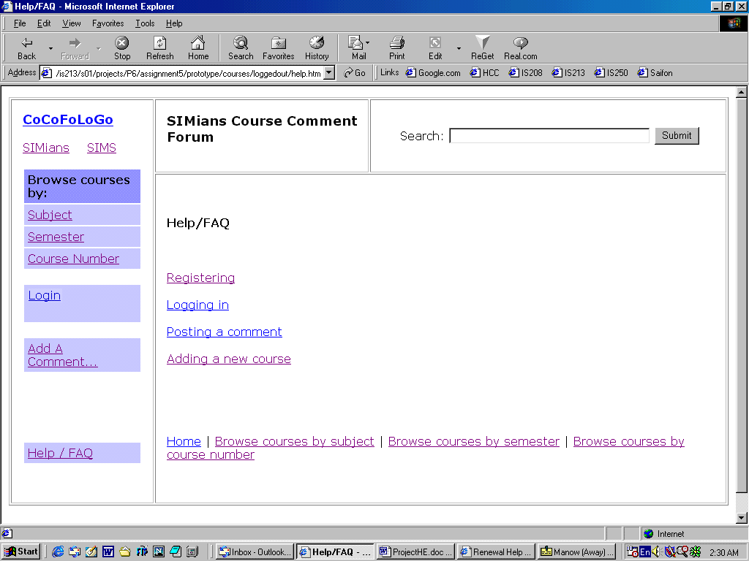

Suggested Solution: Have all help content on one page and separate each topic by bookmarks.

