SIMS 247 – Information Visualization (Fall 2005)
Professor Marti Hearst
Mike Wooldridge (mikew@sims.berkeley.edu)

Assignment 2: Exploratory Data Analysis

Introduction

For this assignment, I analyzed financial information about campaign contributions and spending for U.S. Congressional elections held between 1993 and 2002. The data was published by the U.S. Federal Election Commission. I came up with three hypotheses about relationships I expected to find in the data, and then attempted to verify or refute the hypotheses using two data analysis applications, Spotfire and Tableau.
Full-size versions of the figures may be viewed here: http://sims.berkeley.edu/~mikew/infoviz/eda/figures.html

Hypothesis #1: There is greater financial support from organized labor for the Democratic Party and greater support from corporate interests for the Republican Party.

Organized labor was associated with the Democratic Party for most of the 20th century, particularly since FDR’s New Deal in the 1930s and 1940s. In contrast, since World War I, the Republican Party has been associated with corporate interests.

To explore labor and corporate support for Democratic and Republican candidates, I looked at contributions from Political Action Committees (PACs) from all years in the data set, filtering out contributions to third-party candidates. The data set includes information about contributions from six classes of PACs: Corporate, Labor, Non-Connected, Trade/Membership/Health, Cooperative, and Corporation Without Stock.

Using Spotfire, I created a bar chart that displayed the total contributions of the different classes of PACs. As predicted, contributions from the labor PACs contributions heavily favor the Democrats over the Republicans ($173 million versus $15 million). Corporate PACs contribute more to the Republicans than to the Democrats ($216 million versus $98 million), as do Corporations Without Stock ($9.8 million versus $6.8 million). The other four types of PACs also contribute more money to Republicans.

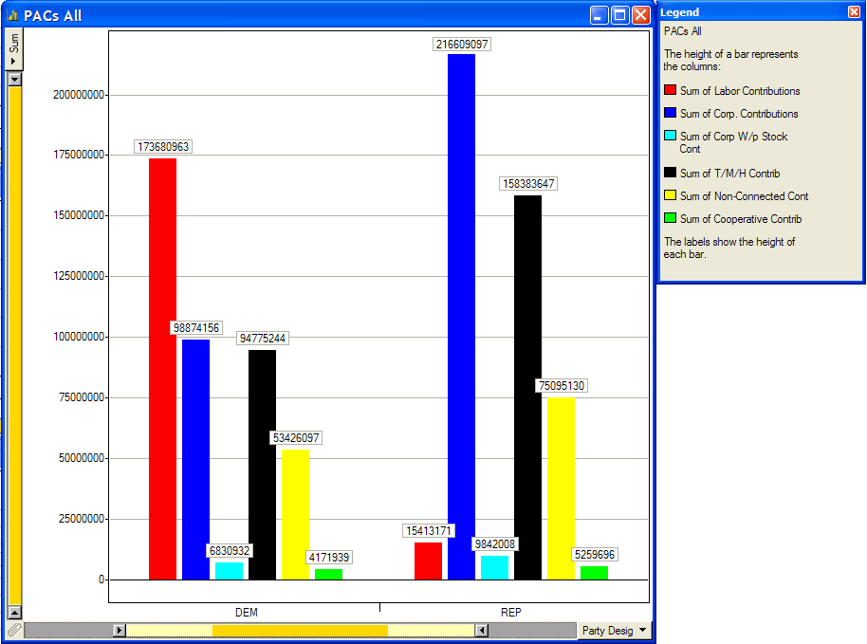
Figure 1. Contributions from PACs to Democratic and Republican candidates in House and Senate elections (1996-2002). Labor PACs favor Democrats while corporate PACs favor Republicans.

Next, I looked for interesting trends in PAC contributions by examining the total receipts plotted against years. Using the “Party Desig” checkboxes under the Spotfire Query Devices, I was able to look at contributions to Democrats, to Republicans, and to candidates from both parties.

As seen in Figure 2, there was a drop in labor support between 1996 and 1998 for the Democrats (total receipts declined 5.0%). This is in contrast to contributions from the other large classes of PACs (Corporate, Trade/Membership/Health, Non-Connected), which saw a gradual increase over all years from 1996 to 2002. It would be interesting to try to correlate this drop with a change in the relationship between the Democratic Party and labor unions or the economic state of labor unions. An alternate explanation could be that this slip was due not to a low 1998, but to a high 1996. I could examine 1994 data to determine this.

There was also a large increase in donations in the Non-Connected category from 1996 to 2002 (see Figure 3). Contributions increased 103% (from $21.8 million to $44.4 million) over that time, a much steeper rise than was seen in any of the other PAC classes. It could be that the rules governing Non-Connected PACs were more lax than those governing the other classes during this time, which encouraged more groups to organize under this classification.

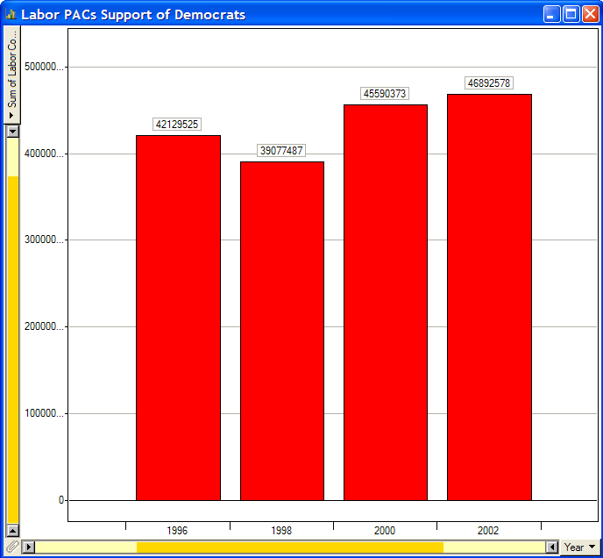  Figure 2. Contributions to Democratic candidates from Labor PACs in Senate and House elections (1996-2002). Note the drop in 1998 contributions. | 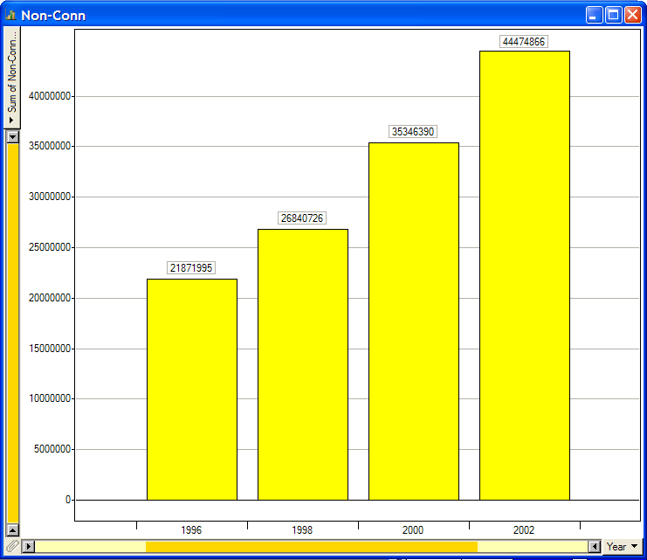  Figure 3. Contributions to Democratic and Republican candidates from Non-Connected PACs in Senate and House elections (1996-2002). Contributions from these PACs had the greatest percentage increase.

Hypothesis #2: As a group, challengers should receive more total receipts compared to incumbents.

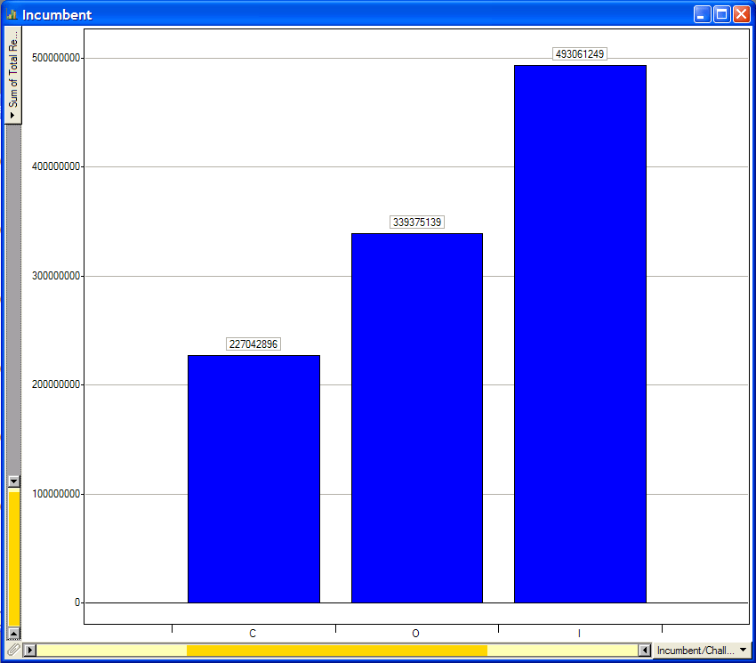
Figure 4. Total receipts of challenger (left), open-seat (middle), and incumbent (right) candidates for House and Senate races (1996-2002). Incumbents attract the most money.
A typical Congressional race involves one incumbent and multiple challengers (or no incumbent, in the case of an open-seat race). This is consistent with the makeup of the data set, which includes 5,516 challengers, 1,717 incumbents, and 1,983 open-seat candidates. Consequently, one might expect that the challengers, as a group, would reap more contributions.

I used a bar graph in Spotfire to analyze how the receipts were divided among the different types of candidates in both House and Senate races from 1996 to 2002 (see Figure 4). The results were contrary to what I expected. Challengers received the least amount of total receipts ($227 million) while incumbents received the most ($493 million). Open-seat candidates were in the middle with $339 million.

This suggests that the sheer number of candidates in a category plays a lesser role in determining how much money is received. The results make sense when you consider that 1) third-party candidates, who don’t raise as much money, make up a large number of the challenger and open-seat positions; 2) Democrats and Republicans, who can typically raise more money, hold most of the incumbent positions; and 3) candidates who have already won elections—e.g., incumbents—tend to have significant popular support and can attract more contributions. I could also be skeptical and raise the question of whether generous contributions to incumbents might be made with the expectation of quid pro quo.

Next, I wanted to check for outliers that could be skewing the totals in Figure 4. Using Spotfire’s scatter-plot feature, I discovered that there were four open-seat candidates in 2000 Senate races that differed significantly from the rest of the bunch:

- John Corzine (Democratic, New Jersey): $63 million
- Hilary Clinton (Democratic, New York): $42 million
- Rick Lazio (Republican, New York): $39 million
- Rudolph Giuliani (Republican, New York): $24 million

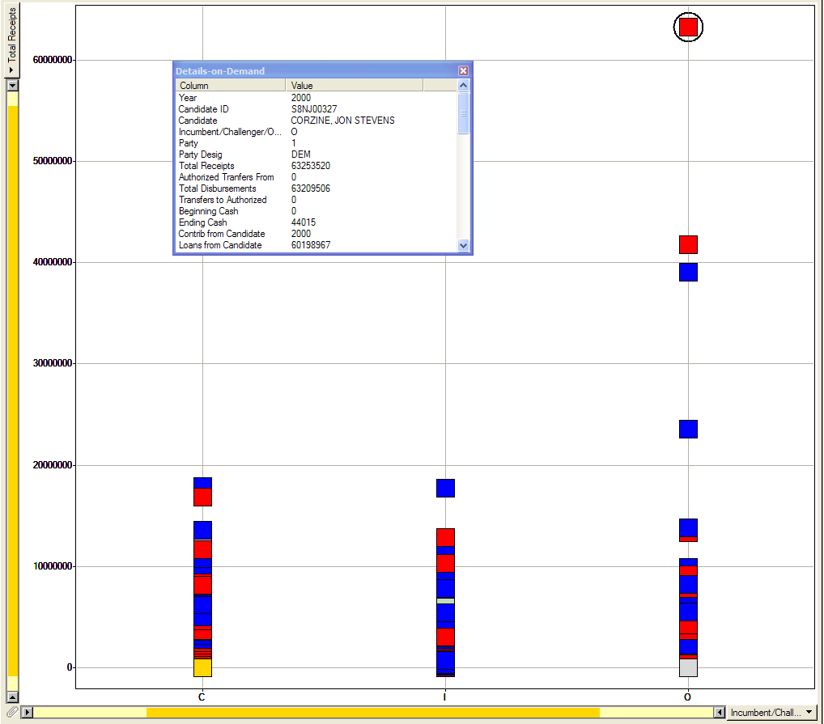
Figure 5. Total receipts for individual candidates organized by challengers (left), incumbents (middle), and open-seat candidates (right) for House and Senate races (1996-2002). Democratic candidates are red while Republican candidates are blue. (Other colors represent third-party candidates.)

When you reduce the receipt totals for these candidates to more typical levels, the open-seat receipt totals seen in Figure 4 drop below those of the challengers.

The outliers intrigued me, so I explored them further with Spotfire’s profile chart, which let me use brushing to pinpoint the sources of their large contributions.

Figure 6. 2000 Senate candidates with high total receipts.
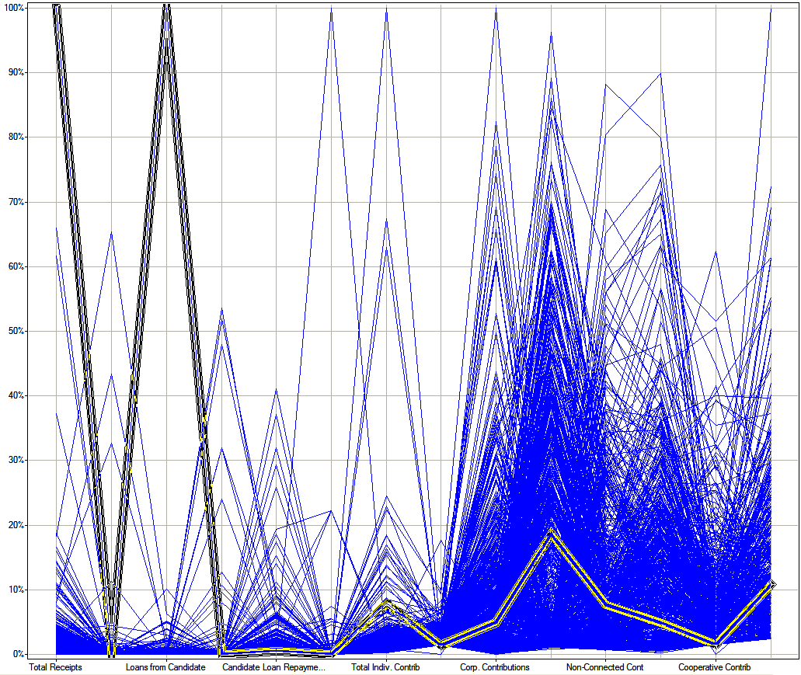  John Corzine | 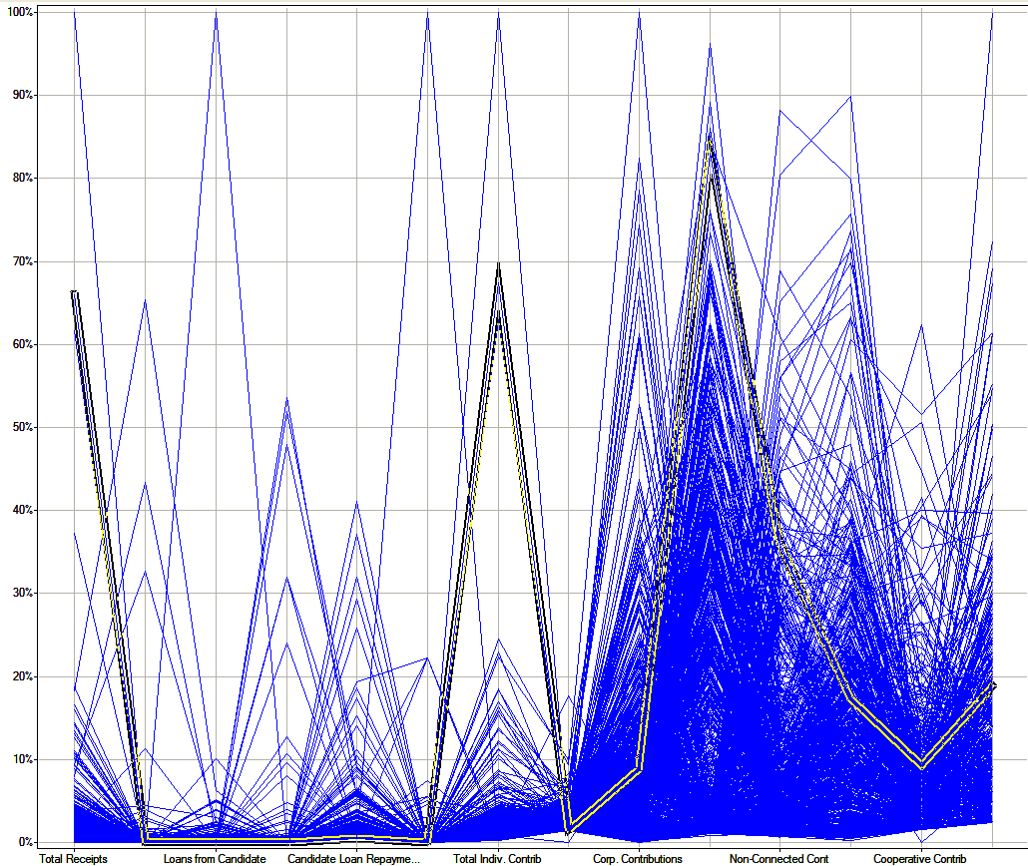  Hilary Clinton
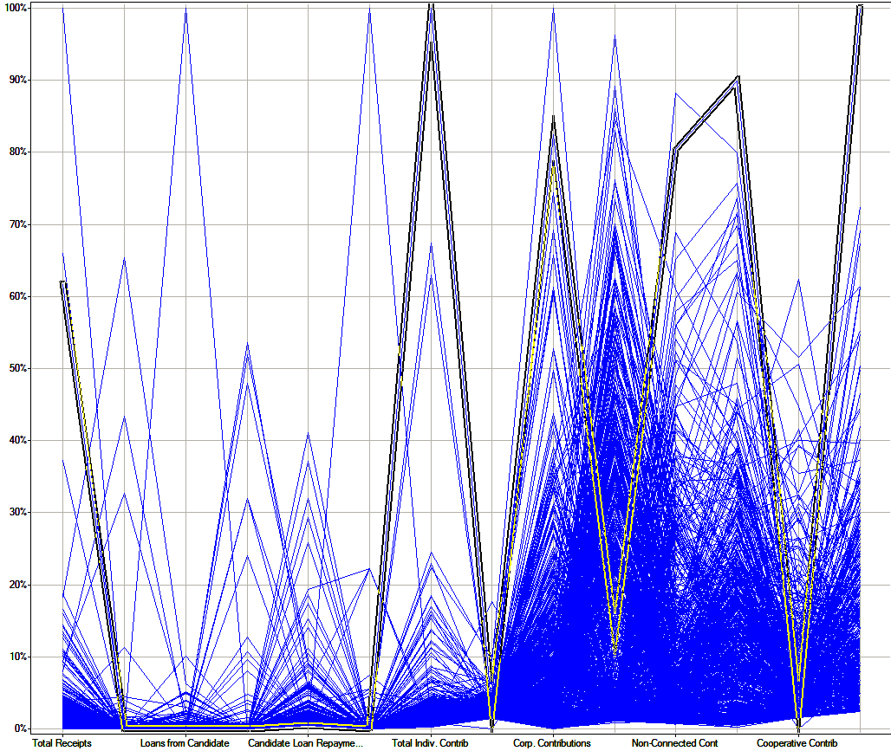  Rick Lazio | 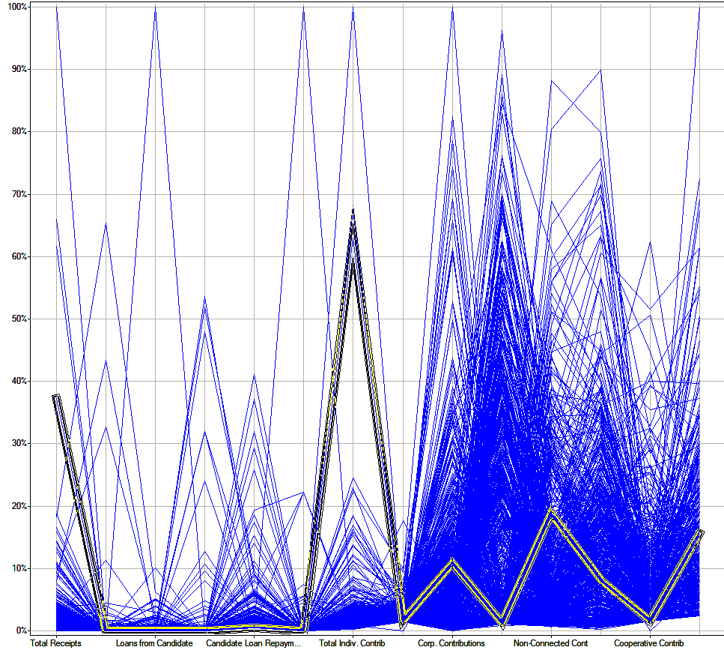  Rudolph Giuliani

John Corzine (Figure 6, top left): Almost all of his $63 million came from his own pocket. His Loans From Candidate figure ($60 million) dwarfs that of all other candidates for his 2000 Senate race. (He won the race, so maybe it was worth it.)

Hilary Clinton (Figure 6, top right): She had large contributions from individuals as well as labor PACs (which is consistent with her Democratic affiliation).

Rick Lazio (Figure 6, bottom left): He had lots of support from individuals (more than Clinton, his opponent) and large contributions from corporate PACs (which is consistent with his Republican affiliation).

Rudolph Giuliani (Figure 6, bottom-right): The spikes in this graph are similar to Giuliani’s fellow Republican Lazio’s, albeit smaller in magnitude. (Giuliani dropped out of the 2000 Senate race before the primary.)

Finally, I switched to a stacked bar chart to examine how the different types of PAC contributions were spread among the candidate types. The results (see Figure 7) show a large disparity between what PACs contribute to incumbents and what they contribute to non-incumbents, much more than was seen in the comparison of total receipts in Figure 4. (With the vast sums of money being donated to incumbents by special interests, I can understand why many have been pushing for campaign finance reform in recent years.)

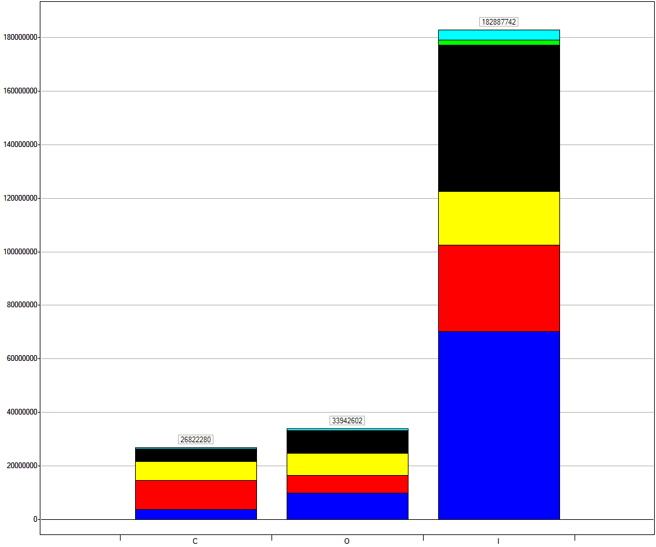
Figure 7. Total PAC contributions to challenger (left), open-seat (middle), and incumbent (right) candidates for House and Senate races (1996-2002). Colors represent the six classes of PACs. (See Figure 1 for details.) Incumbents attract most of the PAC money by far.

Hypothesis #3: The number of individual contributions will be correlated with the size of the population of a state.

This hypothesis assumes that individuals in different states don’t vary in their tendency to contribute to House and Senate campaigns—that the average Californian is just as likely to contribute as the average Alaskan. It also assumes that individuals tend to contribute to candidates from their own state.

In Tableau, I created scatter plots mapping state populations against the number of individual contributions from the states (see Figure 8). I built separate scatter plots for House and Senate candidates. The population data was not in the original FEC data set, so I added it in a new column in the CSV file. (Note that I did not vary the populations for the different years, and used 2003 population estimates.) I also created a new calculation in Tableau that summed the number of individual contribution columns for “#$200-$499 Contrib,” “#$500-$749 Contrib,” and “$750+ Contrib.” Lastly, I created a new calculation that distinguished House candidates from Senate candidates using the first letter in each candidate’s ID.

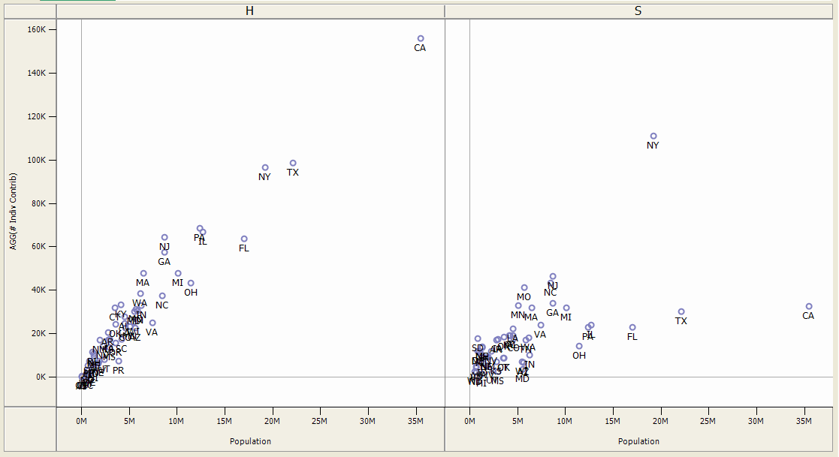

Figure 8. Scatter plots comparing state populations to total individual contributions for House and Senate races (1996-2002).

Comparison of the House and Senate scatter plots: The correlation between population and contributions appears relatively strong in the House plot. In the Senate plot, the correlation is weaker, with the marks more scattered. This could be explained by the fact that there are fewer Senate candidates (1,139) than House candidates (8,077), and therefore you might see highly contentious House races—with a higher-than-normal number of contributions—averaged out by less contentious races in a given year. There is also a flatter slope for the Senate scatter plot, with total contributions in the high-population states (California, Texas, Florida) being lower than several states with smaller populations. This could be explained by the fact that representation varies with population in the House but not the Senate. More parity in power among states when it comes to Senate seats could mean less variation in the number of individual contributions among states.

Analysis of the House scatter plot: While the marks in the House plot tracked along a relatively straight line, there are some deviations from that line that are interesting. Marks that are aligned vertically show states with similar populations but with different contribution totals. For instance, New Jersey and North Carolina are both about 8.5 million in population, but New Jersey had 65,000 contributions while North Carolina had only 37,000. Marks that are aligned horizontally show states with similar individual contributions but different populations. For instance, while New Jersey has a population about half that of Florida, the two states had about the same number of contributions. From the graph, it appears that New Jersey has a more politically active populace.

Analysis of the Senate scatter plot: In the Senate graph, I also see New Jersey having a relatively high mark in terms of contributions, with North Carolina and Missouri right below it. However, the extreme outlier is New York, whose 111,000 contributions were more than twice those of New Jersey, the second-place state. As I discovered when investigating Hypothesis #2, the year 2000 included a highly funded Senate race between Hilary Clinton and Rick Lazio in New York. The race skews the totals for that year.

To delve deeper into how contributions were distributed, I added a third variable to the mix: incumbency. I used Tableau’s tools to build a grid of small multiples (see Figure 8) that compared the different factors—incumbency, race type (House or Senate), population, and number of individual contributions.

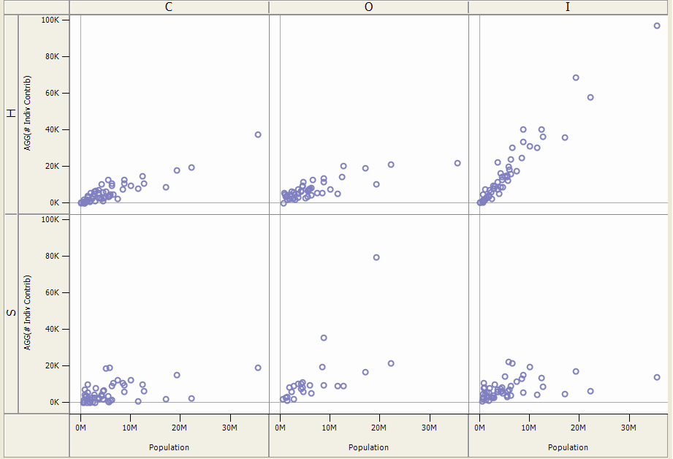

Figure 8. Scatter plots comparing state populations to total individual contributions for challengers, open-seat candidates, and incumbents in House and Senate races (1996-2002). Contributions to House incumbents (top right) show a different trend.

The results were surprising. Five of the scatter plots (all three Senate graphs, plus the House graphs for challengers and open-seat candidates) displayed similar distributions, with most contribution totals below 20,000 (with New York being the extreme outlier in the open-seat Senate graph). The odd graph in the group is the one for the incumbent House candidates; here we see a much higher number of contributions being made across all the states.

Having seen the interesting results of the scatter plots, I decided to return to the type of analysis I had done for Hypothesis #2 (which looked at total receipts for incumbents). As shown in Figure 9, total receipts were much higher for incumbent candidates in House races. Total receipts for incumbents in Senate races were similar to those for the non-incumbent groups.
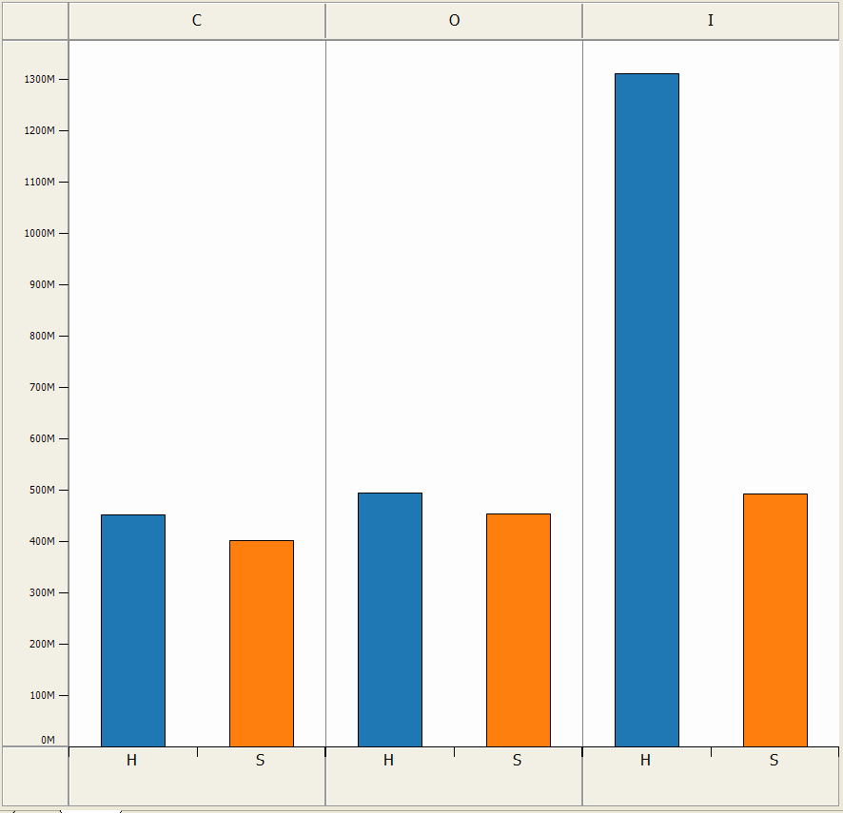
Figure 9. Total receipts for challengers, open-seat candidates, and incumbents in House and Senate races (1996-2002). House incumbents, as a group, take in the most receipts.

Comparison of Tableau and Spotfire

For the most part, I really liked Tableau’s interface. The lists of fields on the left side gave me a nice overview of the available data, while the drag-and-drop “shelves” let me easily experiment with different graph types. While it was hard to predict what kind of graph would come up when I dragged fields onto the shelves, I could usually construct something useful by rearranging the fields or adjusting the aggregate functions in the drop-down menus.

While Spotfire’s interface is more constrained—with a drop-down menu on each axis—the design makes it easy to quickly build graphs that compare two data fields at a time (although I was able to add dimensions using the Document Properties dialog box). One thing I didn’t like about Spotfire was the cluttered window of “query devices” on the right side. The always-visible checkbox and slider filters took up lots of space, which meant I usually had to scroll to find the field I wanted in the window.

An interesting difference that I encountered while testing my hypotheses involved how the two applications support calculated fields. I found that the affordances in the Tableau interface (the field lists and their accompanying menus) made it easy to figure out how to add calculated fields to my lists. By adding a field that distinguished House and Senate candidates, I was able to discover an interesting trend: that individual contributions to incumbent House candidates were much higher than those made to other types of candidates.

In Spotfire, the elements in the query devices window appeared static and unchangeable, and it wasn’t clear to me how or even if I could add new calculations to that window. It was only after accomplishing the task in Tableau and thinking “I must be able to do this in Spotfire!” that I poked around and discovered the “New Column” command.

The assignment reminded me that it isn’t always enough for an application to provide a feature; it also must make it obvious that the feature exists, and use language that effectively communicates how to use it.

Lastly, I liked how I could easily generate small multiples with a common set of axes in Tableau. A frustration I had with Spotfire was that it was difficult to make axes across a group of graphs consistent, since each graph lived in a separate window.

http://www.fec.gov/
http://www.spotfire.com/
http://www.tableausoftware.com/
http://ap.grolier.com/article?assetid=0082980-0
http://ap.grolier.com/article?assetid=0245550-0
Given the large number of candidates, this seemed to be a relatively space-efficient way to hunt for outliers versus, for instance, a sorted bar graph.
http://www.answers.com/topic/rudolph-giuliani
http://www.opensecrets.org/news/campaignfinance/index.asp
http://geography.about.com/cs/censuspopulation1/a/2003estimates.htm

